

Student and Tutor Outcomes

Report on Academic Year 2023-24

Updated 1/28/2025

This project is in collaboration with and funded, in whole or in part, by the Illinois State Board of Education and the Illinois Board of Higher Education supported with federal COVID-relief funds.

Table of Contents

Executive Summary 3

Tutored Students 5

Outcomes, Attendance, and Perceptions 7
Tutored Student Growth – Reading 7
Student Reading Motivation 9
Tutored Student Growth – Math 12
Attendance Rates 15
Student Session Feedback 15
Student Demographics 17
Student Languages Spoken 19

Tutors 20

Self-Efficacy, Training, and Fidelity 22
Tutor Self-Efficacy 22
Tutor Training 24
Tutor Fidelity 25
Tutor Session Feedback 26
Tutor Demographics 26

Institutional and District Partners 29

Tutoring Sessions 38

High School Math Tutoring…………………………………………………………………………………….. 39
Student Demographics………………………………………………………………………………………. 39
Student Growth…………………………………………………………………………………………….... 42
Student Session Feedback…………………………………………………………………………………... 44
Tutor Session Feedback………………………………………………………………………………………45
Tutor Fidelity………………………………………………………………………………………………….45
Tutor Training………………………………………………………………………………………………....46
Attendance Rates……………………………………………………………………………………………..47
Districts and Schools…………………………………………………………………………………………..47
Tutoring Sessions……………………………………………………………………………………………...48

Conclusion 49

Executive Summary

The Illinois Tutoring Initiative (ITI) originated from the Illinois P-20 Council's efforts in spring 2021 to identify evidence-based strategies for learning renewal and to provide support for students, educators, and the broader community as part of pandemic recovery. The P-20 Council's Learning Renewal Resource Guide (March 2021) outlined 12 priority areas for learning recovery, with a specific emphasis on extended learning experiences through high-impact tutoring. As a result, high-impact tutoring was selected as one of four key initiatives for statewide implementation. Additionally, Illinois' higher education strategic plan, A Thriving Illinois, emphasizes closing equity gaps in education through Equity Strategy 1: supporting the ongoing learning renewal of students and the adoption of evidence-informed student support practices. The Illinois Tutoring Initiative represents a collaboration between higher education institutions and K-12 priority school districts to enhance student learning in reading and math for grades 3-8 and high school math tutoring.

The Illinois Board of Higher Education (IBHE) was contracted by the Illinois State Board of Education (ISBE) to collaborate with higher education partners, including the Illinois Community College Board (ICCB), in developing and implementing high-impact tutoring for priority districts across Illinois. These agencies, along with the Governor’s Office Learning Renewal team, have worked in partnership to guide the creation and execution of the Illinois Tutoring Initiative. Seven higher education institutions are involved in delivering high-impact tutoring: Governors State University, Illinois Central College, Illinois State University, Northern Illinois University, Southeastern Illinois College, Southern Illinois University Carbondale, and Southern Illinois University Edwardsville. Illinois State University also provides administrative oversight including tutor training and development, tutor matching and scheduling, data collection, and research.  The mission of the Illinois Tutoring Initiative is to build confident learners through high-impact tutoring. This report provides an overview of student and tutor outcomes for the 2024 Academic Year (AY24; 2023-2024 school year), along with demographic information. It also includes insights from students, tutors, and district and higher education partners, shared with permission. Additionally, the report features a separate section on high school math tutoring, which takes place between January 2023 and summer 2024. In summary, during AY24:  Data was analyzed for 3,422 individual students in grades 3-8 who received tutoring services; this number represents the students for which data was submitted; 58% (1,974) were tutored in both fall 2023 and spring 2024; |  | Figure 1: Tutoring Regions and Institutional Partners  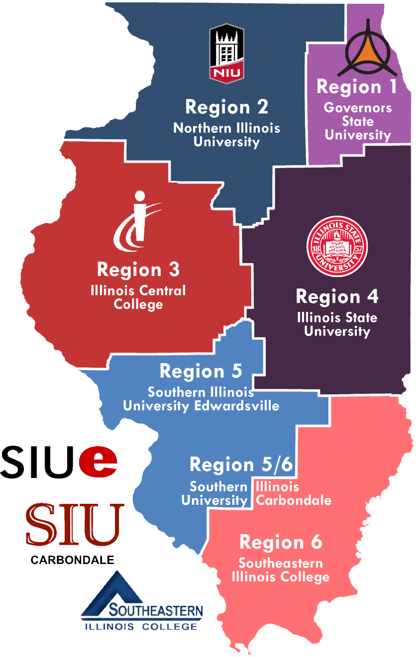

Over 80% of these students (fall = 82%, spring = 83%) were from low-income families;

1,141 trained tutors provided over 134,000 tutoring sessions in reading and/or math; and

69 school districts and 158 school sites were partners in the ITI.

Results for AY24 indicate results consistent with those reported for AY23. Data indicates that across multiple data sources, tutored students made more consistent and more growth in both reading and math than those not tutored between spring 2023 and spring 2024. These results are consistent across both local and state assessments. In reading and math, impacts of tutoring were even greater for students receiving special education services and those who are English Language Learners (ELL). Students tutored in reading were further assessed using a tool to evaluate their reading engagement and motivation

From fall 2023 to spring 2024, students demonstrated statistically significant increases in their confidence to independently sound out difficult words, read difficult books, and felt their skills were more comparable to their peers. Students also noted increased persistence in reading. These beliefs are essential cognitive factors in reading comprehension and contribute to improved reading achievement over time.

At the end of each tutoring session, students were asked to complete an evaluation of the tutoring. Across AY24, students consistently reported high confidence in understanding the material, enjoyment, and learning, with ratings of approximately 90% or higher. These end-of-session ratings from tutored students showed improvement in each category from fall 2023 to spring 2024.

Tutors were surveyed at the start of the fall 2023 semester and the beginning and end of the spring 2024 semester to assess their self-efficacy in their tutoring roles. Self-efficacy refers to one's confidence in the ability to influence motivation, behavior, and the social environment. Tutors responded to questions about their ability to engage students, ask effective questions, provide multiple explanations, and assess student learning. The results show that tutors' sense of self-efficacy increased across several areas, with statistically significant growth observed on the self-efficacy instrument when comparing paired samples over time.

Tutors were trained on the features of high-impact tutoring and asked to self-report their use of the elements of high-impact tutoring after each session. Staff at each of the institutional partners conducted in-person observations of tutors at tutoring sites to conduct additional checks for fidelity to the program and identify areas where tutors might need more support. Across elements of high-impact tutoring, there was alignment between tutors’ self-reported fidelity to the program and the behaviors observed by institutional partners.

Additionally, just as students were asked to briefly reflect on each session, tutors also were asked to complete an exit survey. Approximately 90% of tutors across fall 2023 and spring 2024 reported that the tutoring sessions went well, and that they enjoyed the session. There was growth from fall 2023 to spring 2024 in the percentage of tutors reporting positive student engagement and learning.

Student attendance at tutoring sessions during AY24 continued to lag tutor attendance. While tutors across the state averaged over 95% attendance, student attendance was approximately 75%. Student and tutor attendance is noted to have increased immensely with the full-scale implementation of high-impact tutoring during AY24. High-impact tutoring features the same tutor regularly meeting with the same students for one hour at least three times each week, thus building an authentic relationship. Lower attendance is potentially a limiting factor to the benefits experienced by students. District partners indicated that attendance issues at after-school tutoring sessions, particularly among middle school students, were compounded by competing after-school activities. Transportation was also an issue impacting attendance, despite the efforts of institutional and district partners to implement an array of options to eliminate this as a barrier to attending tutoring sessions.

The Illinois Tutoring Initiative included a research agenda led by scholars at Illinois State University. This report provides a first look at student and tutor outcomes for AY24. Additional scholarly reports will follow to provide a detailed analysis of the findings outlined here.

For more information on the Illinois Tutoring Initiative and its mission to build confident learnings through high-impact tutoring, visit IllinoisTutoringInitiative.org.

Tutored Students

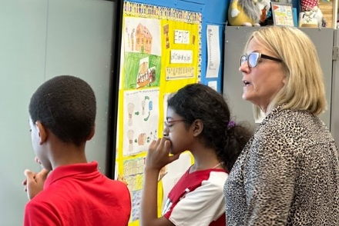 | “When he is in class, he barely speaks a word, but when he comes into tutoring after school, he never stops talking. I have seen his confidence grow so much and he is so comfortable in this small group of students.”

Stephanie Petrich

Burnham Elementary, Burnham School District 154-5

Region 1 – Governors State University
“The best part of tutoring is when we play Uno and math games because it’s fun, and I get to spend more time with my tutor. Tutoring helps me because when I learn something in class, then my tutor teaches me more about it.“ |  | 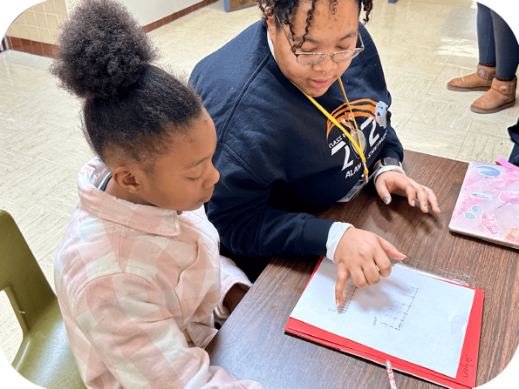

Student

Dekalb Lincoln Elementary, Dekalb CUSD 428

Region 2 – Northern Illinois University
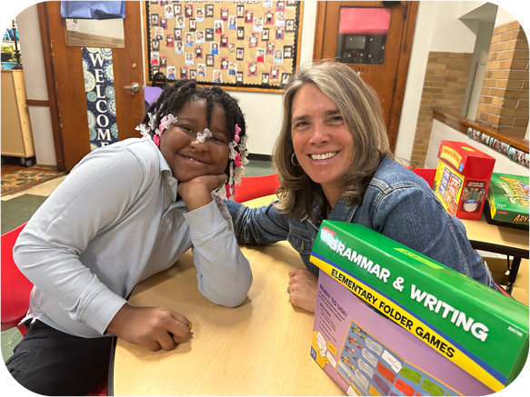 | “I feel like tutoring is helping me because the games, reading out loud, and the phonics book all help me. I have learned about what verbs to use, rhyming words, suffixes, prefixes, contractions, and a lot of other things.”

Student

Franklin Elementary, Peoria School District 150

Region 3 – Illinois Central College
“Tutoring is awesome because my tutor is amazing, and I see my friends. The best is ‘Story Time with John,’ because his stories are great! I can also multiply, divide, and solve equations better.” |  | 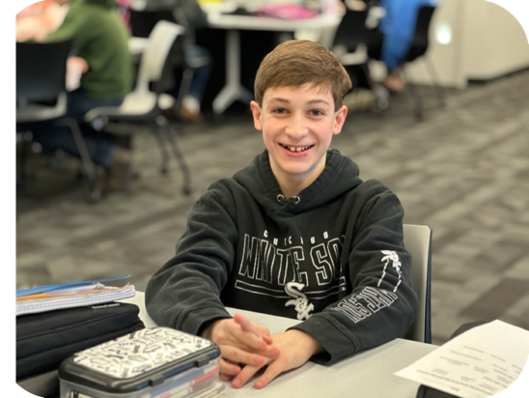

Student

Donovan Middle School, Donovan CUSD 3

Region 4 – Illinois State University
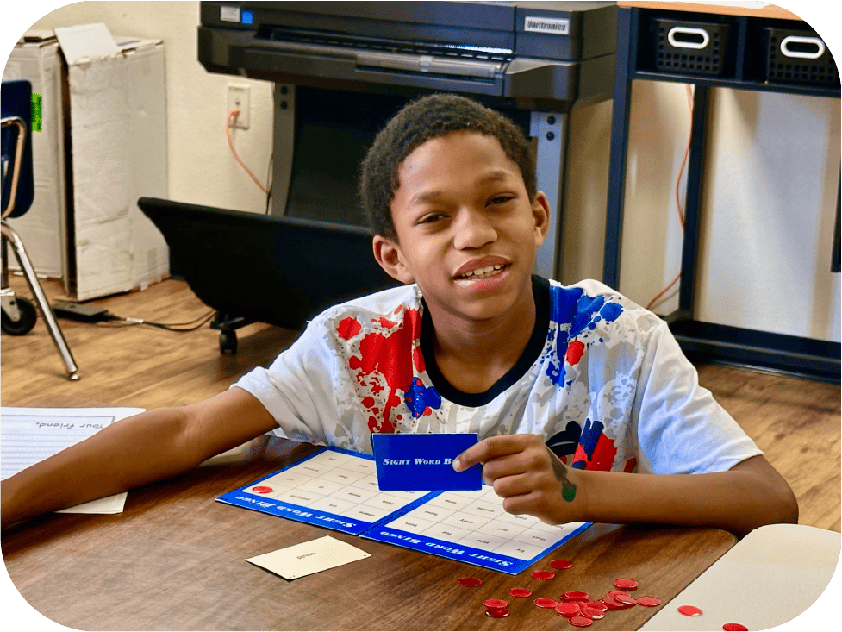 | “I love coming to tutoring. It is one of my favorite parts of the day because I know I will get to have fun while learning new things. It has helped me read and write better. I am also able to do more work in class by myself which makes me feel proud of myself.”

Student

Penniman Elementary School, Cahokia CUSD 187

Region 5 – Southern Illinois University Edwardsville
“It’s fun, but there is work involved. It makes you work hard to get what you want, but that’s OK because the fun balances out the work. You get something good at the end. I like the rewards and all that. I also that that my writing and drawing skills are improving quite a bit. It is getting easier to write.” |  | 
Student
Carruthers Elementary, Murphysboro CUSD 186
Region 5/6 – Southern Illinois University Carbondale

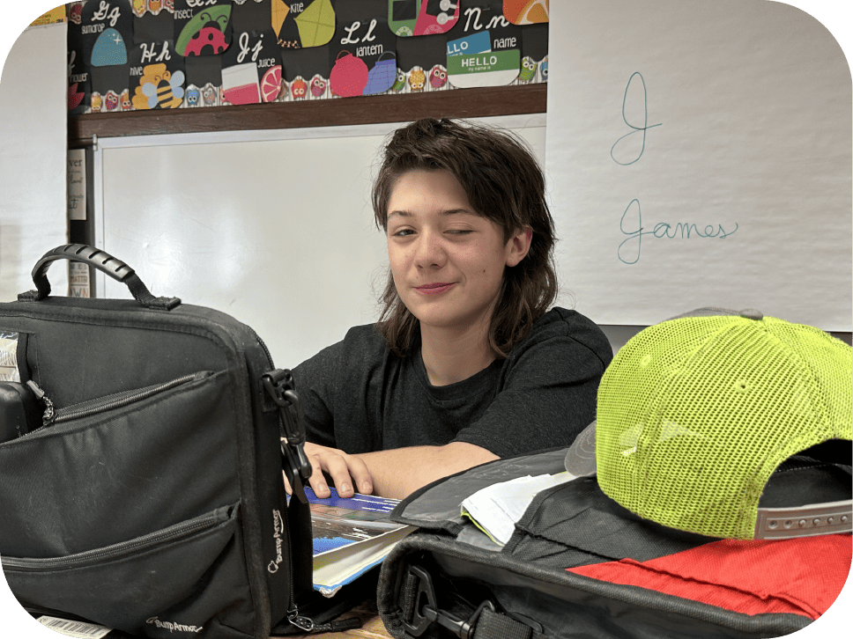 | “Tutoring is helping me by getting my homework, reading, and studies done and taking away that stress. Then I can spend more time at home doing the things I want to do. I haven’t failed any classes at all since I started tutoring. “

Student

Washington Attendance Center, Carmi-White CUSD 5

Region 6 – Southeastern Illinois College

Outcomes, Attendance, and Perceptions

Throughout the 2023-24 academic year, districts submitted interim assessment data for students in reading and math, regardless of the subject area tutored. Numbers reflect students for whom data was available for both points in time (for example, fall 2023 to winter 2023-24; scores were reported for students who had data for both fall 2023 and winter 2023-24 assessment periods). Standard scores on the district-selected interim assessment measured student growth over time. District interim assessments included AIMSweb, Fastbridge, I-Ready, NWEA MAP, STAR Renaissance, and LRIA. If a standard score remained the same between two periods of time, the student made the expected amount of growth during that period. If the score increased, the student made more growth than expected on the local assessment. Student scores on the Illinois Assessment of Readiness (IAR) test were also evaluated for those recommended for tutoring in 2023 and 2024. The IAR is only administered one time each year.

Tutored Student Growth – Reading

State Assessment Data
State data results were evaluated for students who were recommended for tutoring during AY24 by regional personnel (n=6,215 students, 3,422 tutored; 2,793 not tutored). The IAR Reading results indicate that students who were tutored statistically outperformed those who were not tutored during AY 2024 (t_{(5,273)}=2.23, p=.026).

Additionally, tutored students receiving special education services (F_{(1,571)} = 100.65, p<.001) and tutored English lnagugae learner (ELL) students (F_{(1,571)} = 8.82, p = .003) had statistically higher levels of progress.

Local Assessment Data
Results displayed below show how many students met or exceeded expected growth between the noted semesters.

Figure 2: Students Demonstrating Growth in Reading – Number

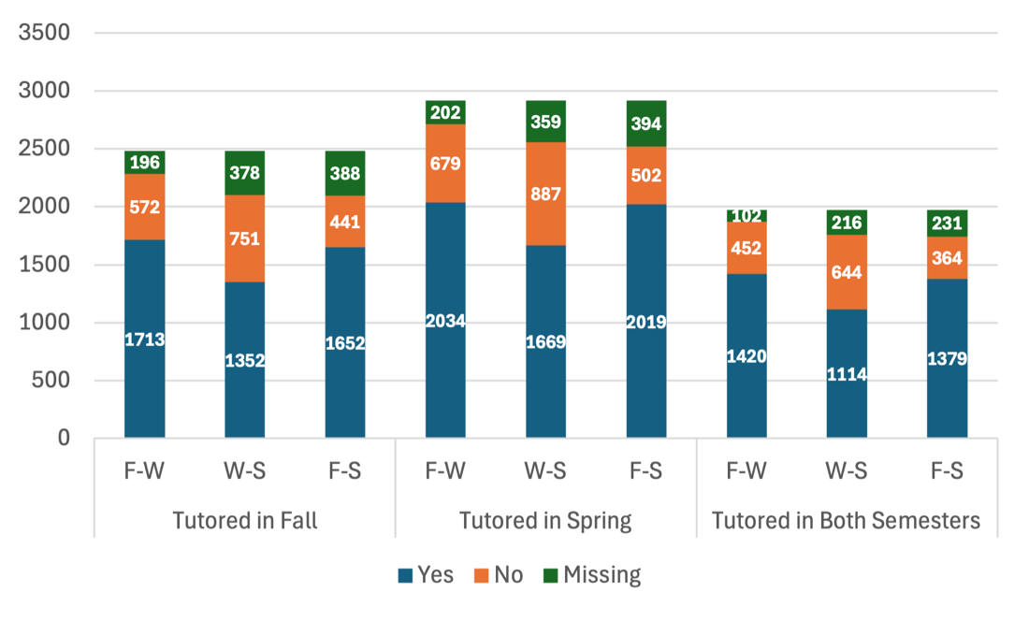

F = fall 2023, W = winter 2023-24, S = spring 2024
3,422 unique students tutored.

Local assessment results indicate that approximately 75% of students with reported data met or exceeded expected growth in reading between fall 2023 and winter 2023-24 and nearly 80% between fall 2023 and spring 2024. This pattern is consistent, whether students were tutored in fall 2023, spring 2024, or both semesters.

Figure 3: Students with Growth in Reading – Percent

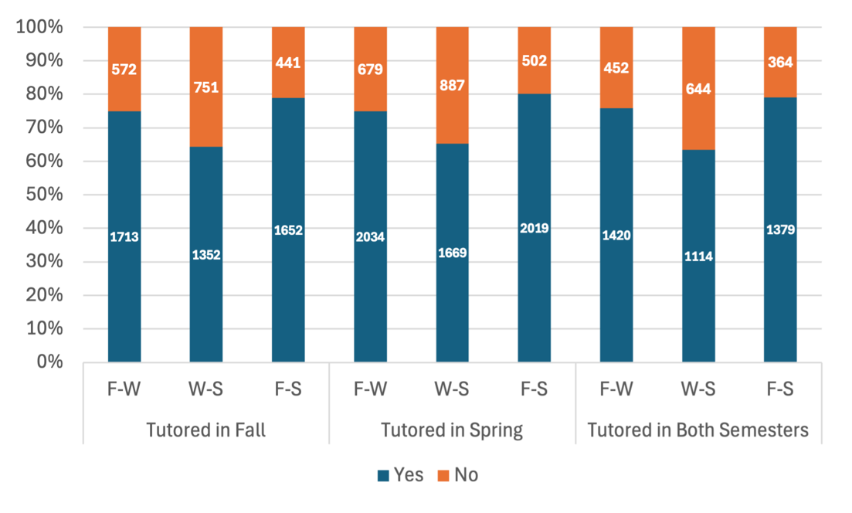

F = fall 2023, W = winter 2023-24, S = spring 2024
3,422 unique students tutored.

When examining reading growth over time, students who were tutored demonstrated more consistent growth in reading compared to their non-tutored peers. Tutored students statistically outperformed their non-tutored peers on the NWEA and LRIA district assessments. On the STAR assessment, tutored students had lower reading scores for spring 2023; however, the scores were nearly identical for spring 2024 (964.1 vs. 962.5).

Figure 4: Estimated Marginal Means of Reading Scores - NWEA

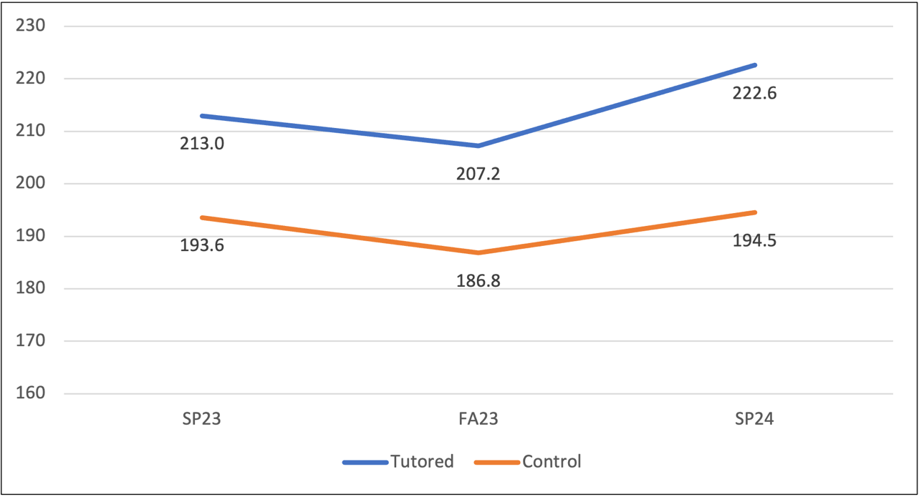

Figure 5: Estimated Marginal Means of Reading Scores – LRIA

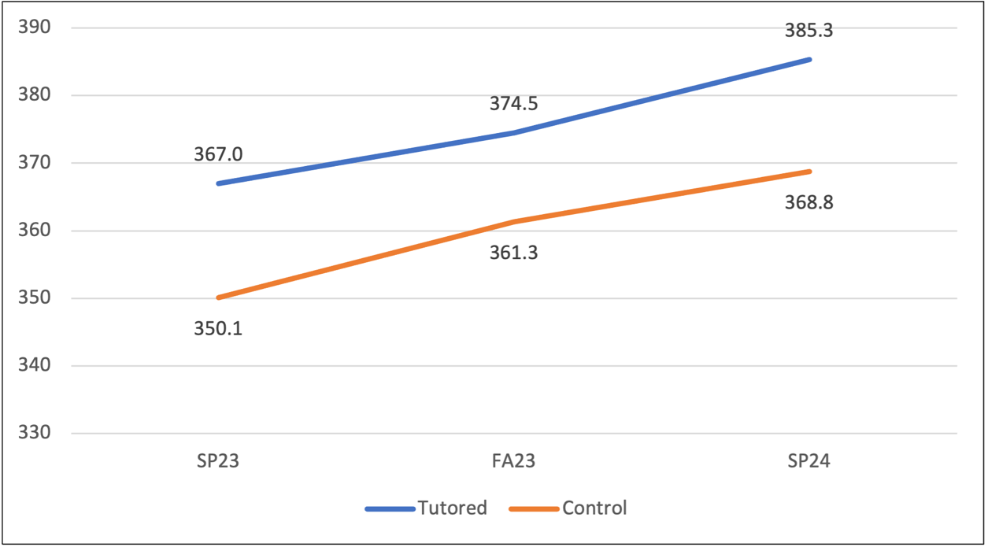

Student Reading Motivation

Reading motivation refers to the goals and beliefs a student holds about the processes and outcomes of reading. Student reading motivation was measured three times in FY24 (start of fall 2023 and the start and end of the spring 2024 semester) through a survey. Growth was seen across all items. Paired survey results across the spring 2024 semester indicate statistically significant increases in several areas. Students demonstrated increased certainty that they could independently sound out difficult words and read difficult books. Students also noted increased persistence and confidence in reading. These beliefs are important cognitive components of reading comprehension and lead to increased reading achievement overtime.

Table 1: Student Reading Survey Questions and Mean Scores
INDEPENDENT SAMPLES

Survey Instructions: Read each item and rate how certain you are that you can do the things described below. | Start of Fall 2023 Semester  (N=82) | Start of Spring 2024 Semester (N=2,107) | End of Spring 2024 Semester  (N=1,941)
Read out loud in front of the class | 3.5 | 5.0 | 5.1
Continue reading even when I find it difficult | 4.2 | 5.4 | 5.5
Work out the sounds in words I have not seen before | 4.0 | 5.5 | 5.6
Sound out a word that I find hard to read | 4.0 | 5.5 | 5.5
Read on my own without an adult’s help | 3.5 | 5.7 | 5.8
Read things that are harder than the books I normally read at school | 4.2 | 5.0 | 5.2
Know what I can do to improve my reading | 5.3 | 5.5 | 5.6
Continue reading even when I find the subject boring | 4.2 | 4.9 | 4.9
Read out loud quickly and still get words right | 4.1 | 4.6 | 4.8
Make out words easily when I read | 4.0 | 5.2 | 5.3
Improve my reading if I really want to | 5.0 | 5.7 | 5.8
Continue reading even when I do not like the subject | 4.0 | 5.0 | 5.0
Read as well as my friends | 4.0 | 5.1 | 5.2
Continue reading even when I get frustrated | 4.3 | 4.7 | 4.9
Practice reading in my spare time even when I don’t have to | 4.0 | 4.5 | 4.6
Read without making lots of mistakes | 3.9 | 4.6 | 4.8
Read difficult books | 3.8 | 4.7 | 5.0
Read a book I have not read before | 4.1 | 5.7 | 5.8
Work out the sounds in words I have not seen before | 4.2 | 5.5 | 5.5

Likert scale: 1-7 with 1=Very certain I cannot do and 7=Very certain I can do

Table 2: Student Reading Survey Questions and Results
PAIRED SAMPLES (N=1,465)

Survey Instructions: Read each item and rate how certain you are that you can do the things described below. | Start of Spring 2024 Semester Mean & SD | End of Spring 2024 Semester  Mean & SD | t-value | p-value | Effect size
Read out loud in front of the class | 5.02 (2.12) | 5.14 (1.98) | t=-2.17 | p=.031* | .057
Continue reading even when I find it difficult | 5.37 (1.74) | 5.52 (1.56) | t=-2.96 | p=.003** | .077
Work out the sounds in words I have not seen before | 5.53 (1.61) | 5.59 (1.52) | t=-1.30 | p=.194 | .034
Sound out a word that I find hard to read | 5.43 (1.60) | 5.49 (1.54) | t=-1.31 | p=.189 | .034
Read on my own without an adult’s help | 5.73 (1.64) | 5.79 (1.56) | t=-1.30 | p=.194 | .034
Read things that are harder than the books I normally read at school | 5.06 (1.79) | 5.22 (1.67) | t=-3.08 | p=.002** | .080
Know what I can do to improve my reading | 5.45 (1.60) | 5.59 (1.47) | t=-2.78 | p=.006** | .073
Continue reading even when I find the subject boring | 4.93 (1.95) | 4.92 (1.85) | t=0.16 | p=.871 | .004
Read out loud quickly and still get words right | 4.58 (1.91) | 4.75 (1.77) | t=-3.26 | p=.001*** | .085
Make out words easily when I read | 5.15 (1.67) | 5.33 (1.50) | t=-3.84 | p<.001*** | .100
Improve my reading if I really want to | 5.69 (1.49) | 5.75 (1.43) | t=-1.22 | p=.224 | .032
Continue reading even when I do not like the subject | 5.06 (1.85) | 5.05 (1.77) | t=0.21 | p=.835 | .005
Read as well as my friends | 5.07 (1.81) | 5.14 (1.73) | t=-1.40 | p=.162 | .037
Continue reading even when I get frustrated | 4.75 (1.95) | 4.88 (1.84) | t=-2.28 | p=.023** | .059
Practice reading in my spare time even when I don’t have to | 4.48 (2.07) | 4.56 (1.99) | t=-1.42 | p=.155 | .037
Read without making lots of mistakes | 4.61 (1.77) | 4.85 (1.66) | t=-4.69 | p<.001*** | .123
Read difficult books | 4.71 (1.90) | 5.02 (1.70) | t=-5.95 | p<.001*** | .155
Read a book I have not read before | 5.75 (1.54) | 5.80 (1.46) | t=-1.15 | p=.251 | .030
Work out the sounds in words I have not seen before | 5.46 (1.58) | 5.50 (1.49) | t=-0.92 | p=.359 | .024
Likert scale: 1-7 with 1=Very certain I cannot do and 7=Very certain I can do
* p<.05 ** p<.01 *** p<.001

Cohen’s effect size interpretation:
Small effect: 0.01 - 0.2
Medium effect: 0.2 - 0.5
Large effect: 0.5 - 0.8
Very Large effect: 0.8 - 1.2

Tutored Student Growth – Math

State Assessment Data

State data results were evaluated for students who were recommended for tutoring during AY24 by regional personnel (n=6,215 students, 3,422 tutored; 2,793 not tutored). The IAR Math results indicate that students who were tutored statistically outperformed those who were not tutored during AY24 (t_{(5,264)}=4.07, p<.001).

Additionally, tutored students receiving special education services (F_{(1,5162)} = 7.18, p<.007) and tutored ELL students (F_{(1,562} = 11.94, p<.001) had statistically higher levels of progress.

Local Assessment Data

Results displayed below show how many students met or exceeded expected growth between the noted semesters.

Figure 6: Students with Growth in Math – Number

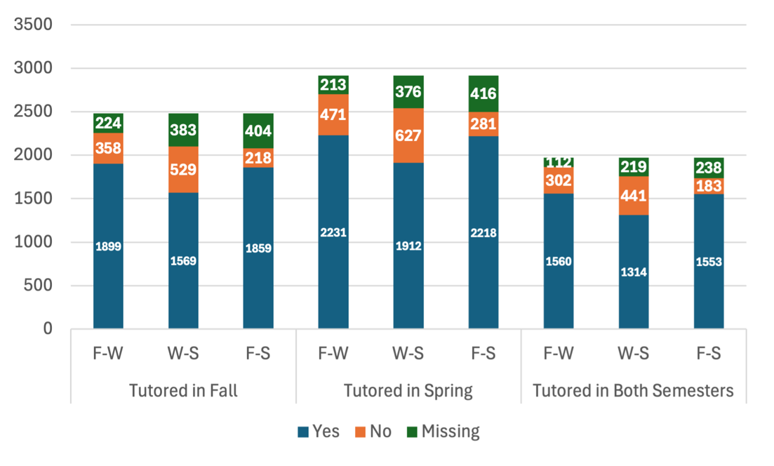

F = fall 2023, W = winter 2023-24, S = spring 2024
3,422 unique students tutored.

Local assessment results indicate that approximately 85% of students with data met or exceeded expected growth in math between fall 2023 and winter 2023-24 and nearly 90% between fall 2023 and spring 2024. This pattern is consistent, whether students were tutored in fall 2023, spring 2024, or both semesters.

Figure 7: Students with Growth in Math – Percent

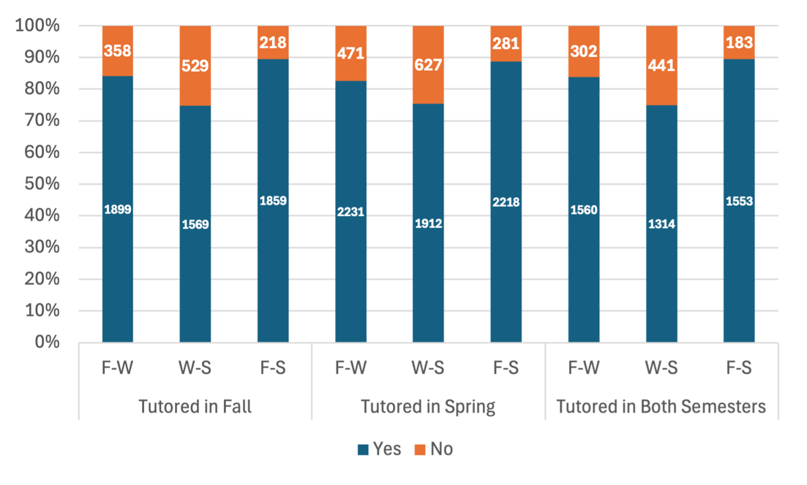

F = fall 2023, W = winter 2023-24, S = spring 2024
3,422 unique students tutored.

When examining math growth over time, students who were tutored demonstrated more consistent growth in math compared to their non-tutored peers. Tutored students statistically outperformed their non-tutored peers on the NWEA, STAR, and LRIA district assessments. For the Fastbridge assessment, tutored students started off with lower math scores in spring 2023; however, the scores for the tutored students exceed the non-tutored students in spring 2024 (206.0 vs. 205.2).

Figure 8: Estimated Marginal Means of Math Scores – NWEA

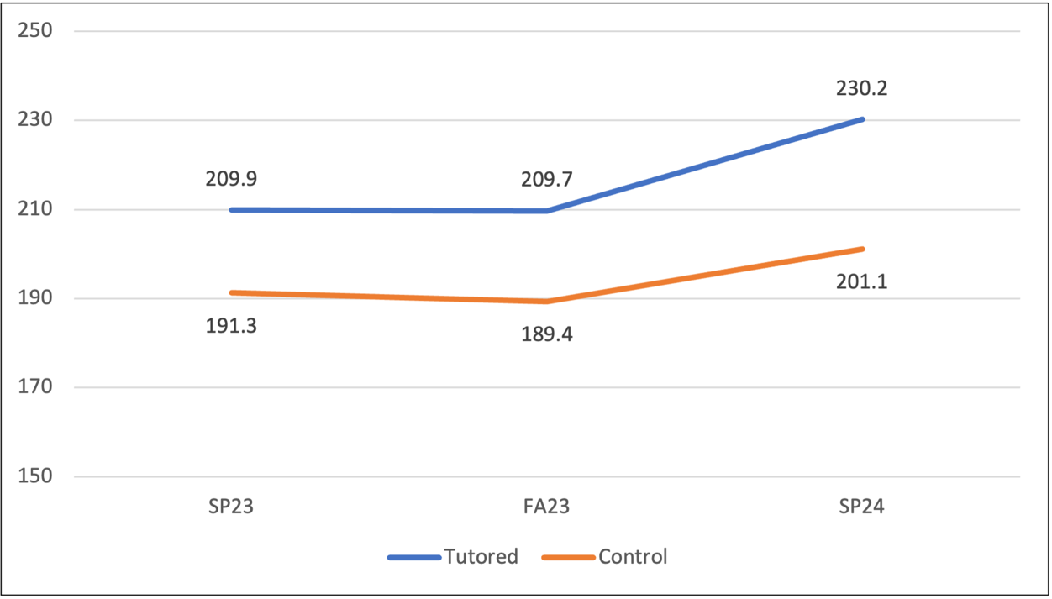

Figure 9: Estimated Marginal Means of Math Scores – STAR

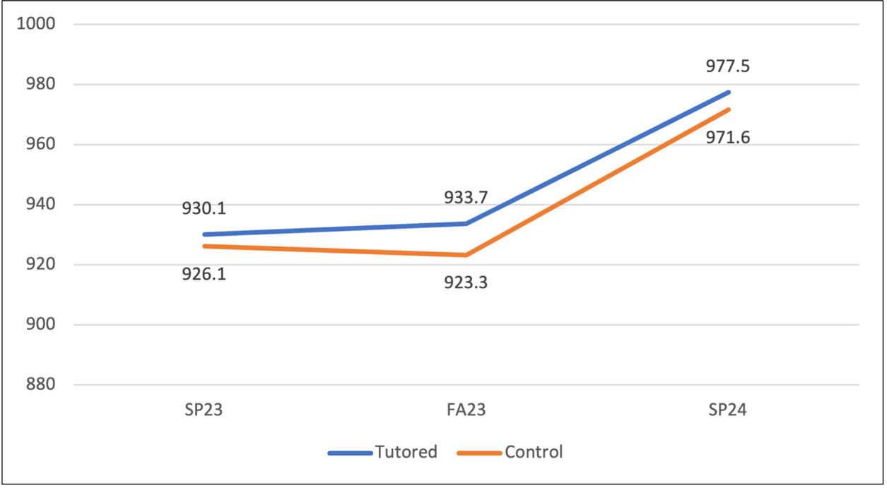

Figure 10: Estimated Marginal Means of Math Scores – LRIA

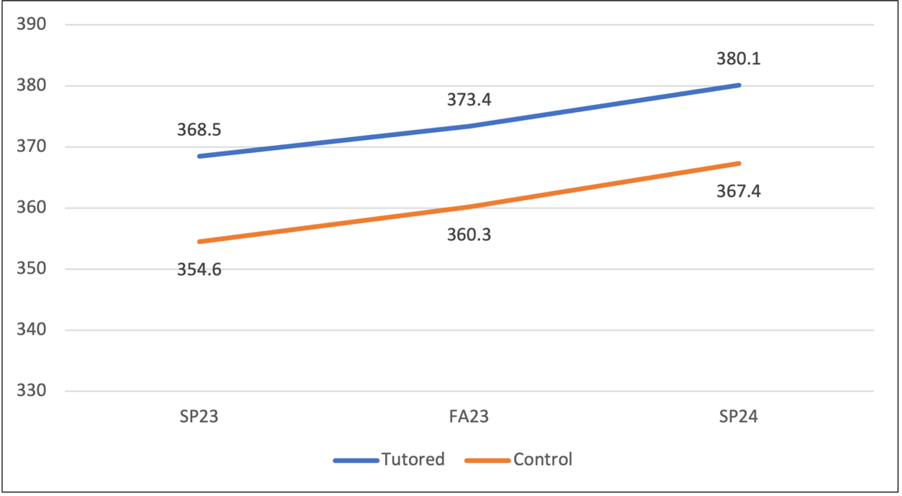

Attendance Rates

While tutors across the state averaged over 95% attendance, student attendance lagged at approximately 75%. Tutor and student attendance are noted to have increased during AY24. Low attendance rates for some tutored students can be a potentially limiting factor to the benefits experienced in tutoring. Districts indicated that attendance issues at after-school tutoring sessions, particularly among middle school students, were compounded by competing after school activities. Transportation was also an issue impacting attendance, despite the efforts of institutional and district partners to implement an array of options to eliminate this as a factor.

Figure 11: Tutor and Student Attendance Rates

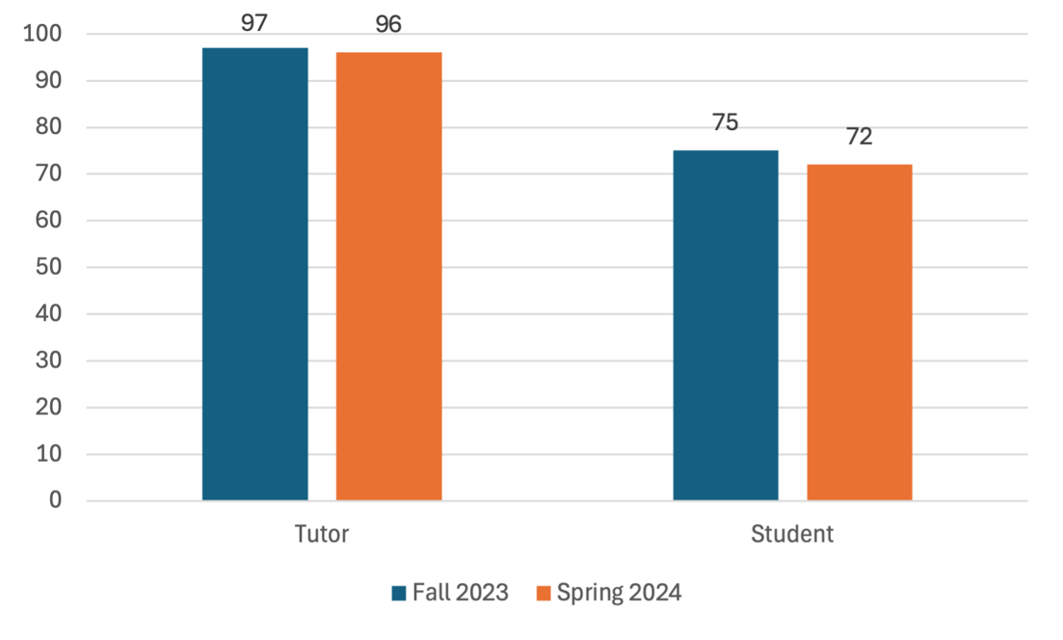
Student Session Feedback

At the conclusion of each tutoring session, students completed a short feedback survey. Results across all students across all sessions are reported below. Students reported consistently high confidence in understanding the material, enjoyment, and learning.

Table 3: Student Feedback Survey Questions and Mean Scores

Question | Fall 2023  (N=48,341) |  | Spring 2024  (N=79,107) |  | Summer 2024 (N=19,991)
Question | Percent* | Average Score | Percent* | Average Score | Percent* | Average Score
How confident are you that you understood the material in this tutoring session? | 94.7 | 4.7 | 96.2 | 4.7 | 96.3 | 4.7
How much did you enjoy this session? | 95.8 | 4.7 | 96.9 | 4.8 | 97.0 | 4.8
How much do you think you learned this session? | 91.8 | 4.6 | 94.5 | 4.7 | 93.7 | 4.6
Overall, how did this tutoring session go? | 96.2 | 4.7 | 97.1 | 4.8 | 97.3 | 4.8

*Percentage of surveys with positive response (4 or 5 on a 5-point Likert scale).
Likert scale = 1-5 with scales differing by question

 | Confidence | Enjoyment | Learning | Overall
1 | Not confident at all | Did not enjoy at all | Almost nothing | Not well at all
2 | Slightly confident | Enjoyed a little bit | A little bit | Slightly well
3 | Somewhat confident | Enjoyed somewhat | Some | Somewhat well
4 | Quite confident | Enjoyed quite a bit | Quite a bit | Quite well
5 | Extremely confident | Enjoyed a tremendous amount | A tremendous amount | Extremely well

Student Demographics

Student participants were served across regions, grades, subjects, income levels, ability levels, and languages spoken. The largest concentration of tutoring occurred in literacy at the elementary level.

Figure 12: Students Tutored by Region

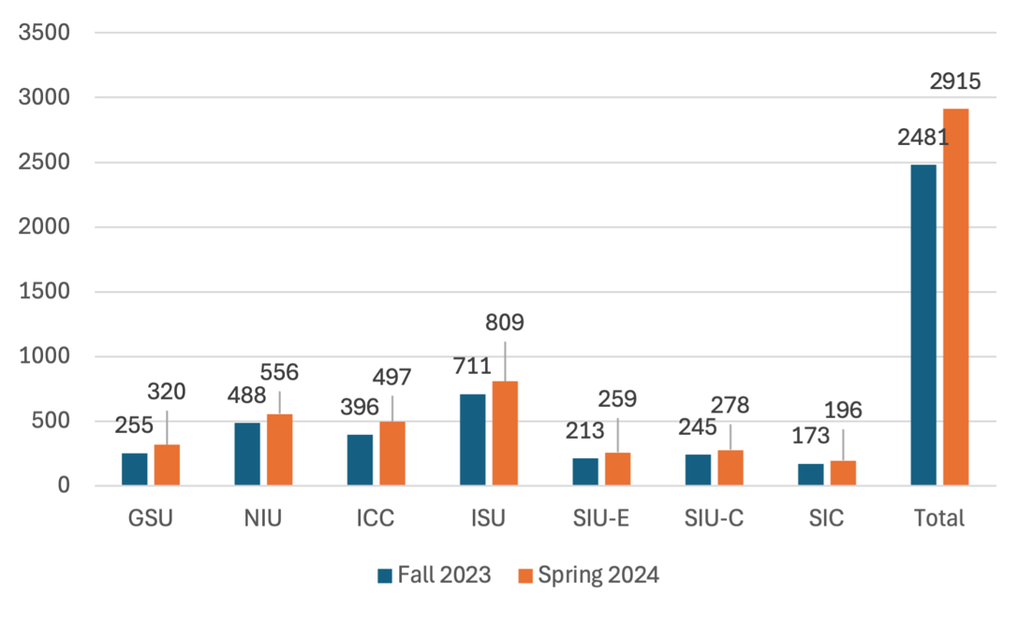
3,422 unique students tutored

Figure 13: Students Tutored by Grade
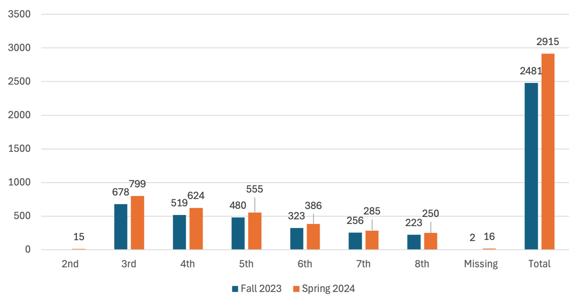

3,422 unique students tutored

Figure 14: Students Tutored by Subject

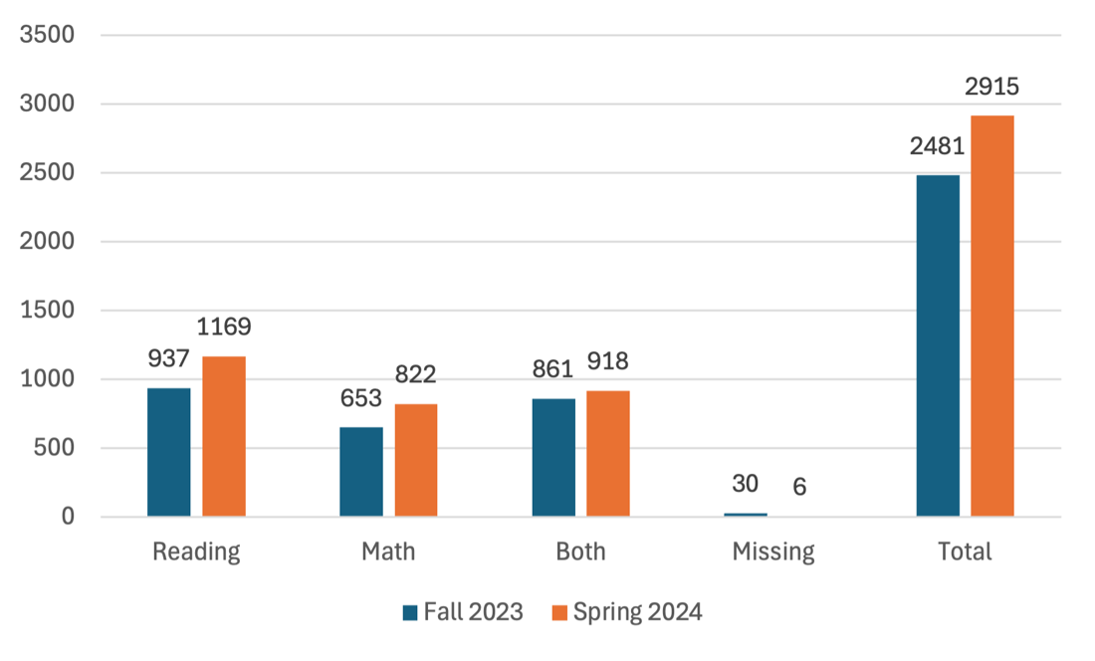
3,422 unique students tutored

Figure 15: Students Tutored by Race

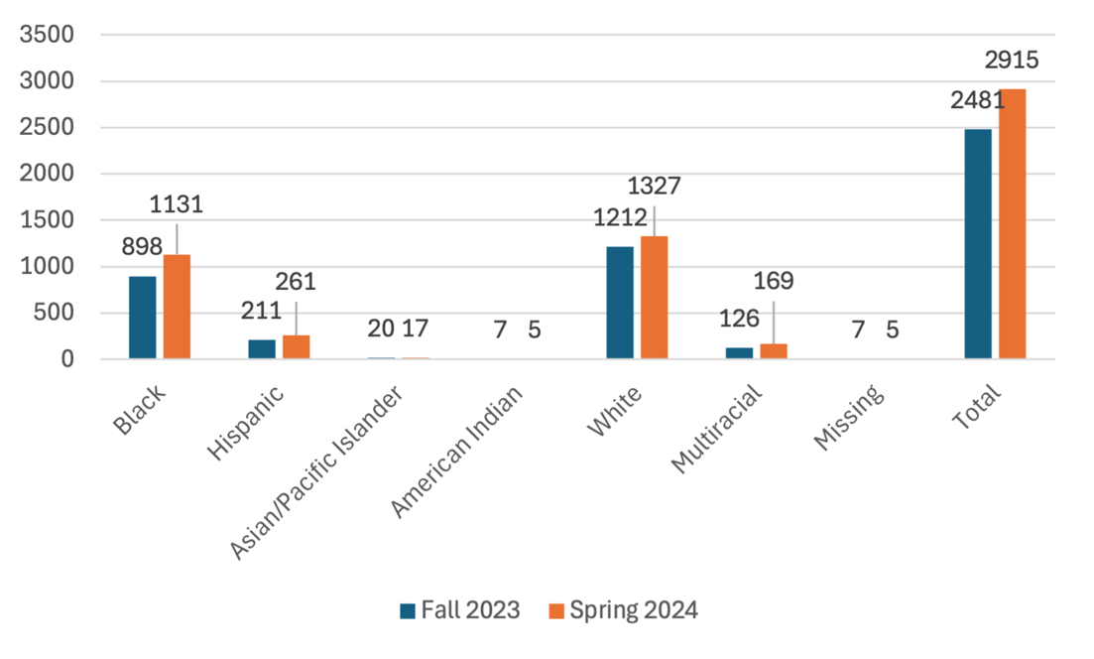
3,422 unique students tutored

Figure 16: Students Tutored by Special Education (SED) Status

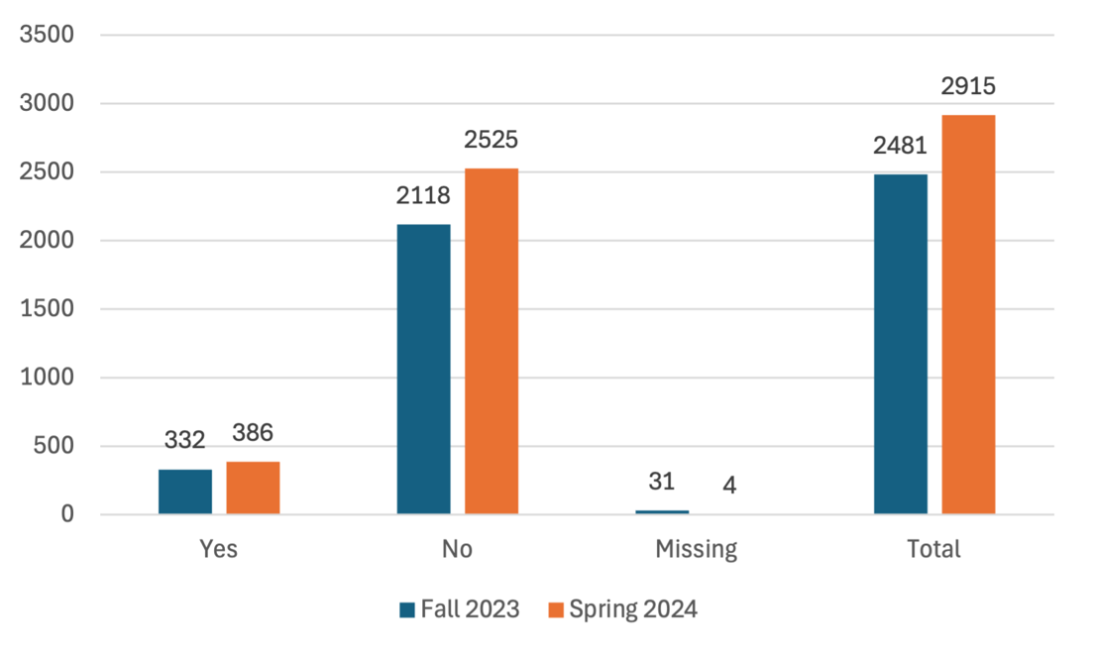
3,422 unique students tutored

Figure 17: Students Tutored by Low-Income Status

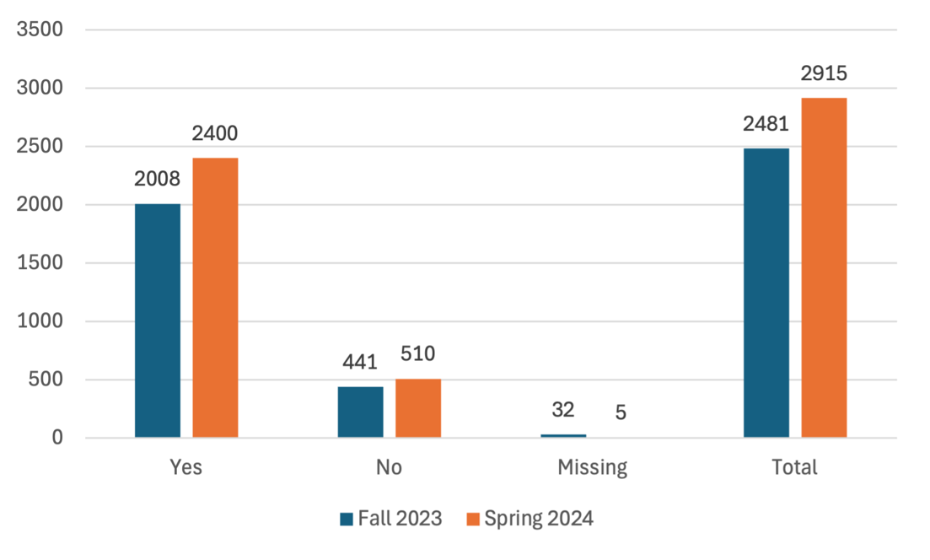
3,422 unique students tutored

Figure 18: Students Tutored by English Language Learner (ELL) Status

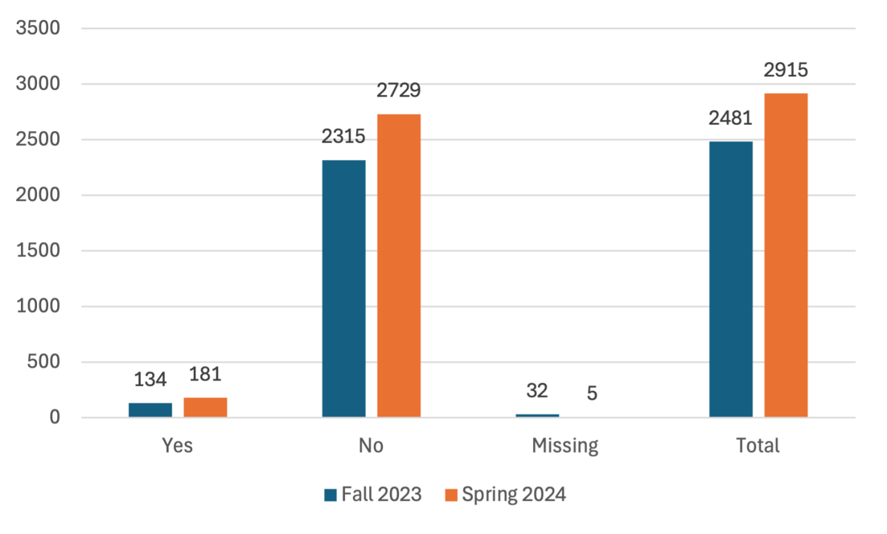
3,422 unique students tutored

Student Languages Spoken

- English
- Spanish
- Arabic
- Iokano
- Polish
- Russian
- Ukranian
- Vietnamese
- Tagalog
- Yoruba
- Greek
- Kinyarwanda
- Kirundi
- Mandrin
- Haitian-Creole
- Swahili
- Q’anjob’ai

Tutors
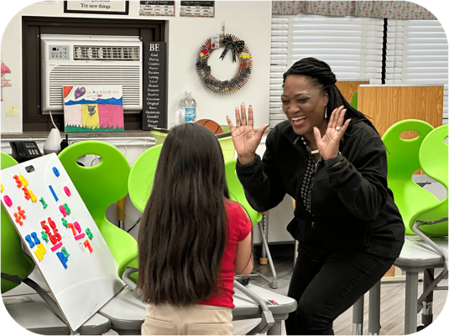 | "The students have been such a blessing to me. When they have an ‘aha moment,’ I am simply overjoyed! It has been rewarding to see the positive impact I am able to provide.”

Darlene Allen-Nichols

Burnham Elementary, Burnham SD 154-5

Region 1 – Governor’s State University
“It is rewarding to be able to help students from different backgrounds and skill levels learn new things and better understand complex concepts. It is also fulfilling to see children improve their understanding and confidence in a subject after receiving tutoring assistance.” |  | 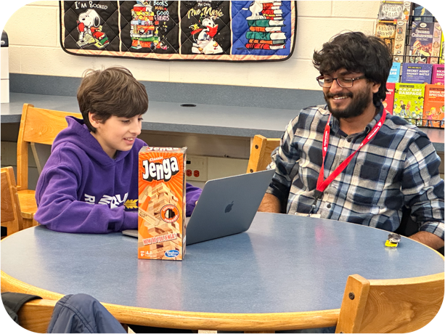
Gopi Vellanki
Rochelle Middle School, Rochelle CCSD 231
Region 2 – Northern Illinois University
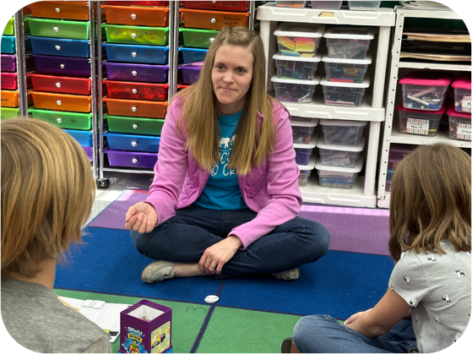 | “We are definitely seeing results in test scores and overall confidence during our practice sessions. I also like that students reflect with us after each lesson. It helps me see what kind of learning style they have and what is working.”
Amy Russell
Marquette Elementary, North Pekin and Marquette Heights SD 102
Region 3 – Illinois Central College
“I am getting positive feedback from parents and students on how tutoring is helping and giving the students the confidence that they need. That is a great feeling. I am seeing students who thought they can’t do well in math now thinking that they CAN do math. They are excited to tell me how they are doing better on their math homework and quizzes.” |  | 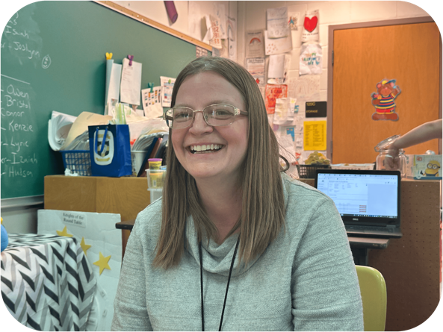
Diana Kerner
Tuscola Northward Elementary, Tuscola CUSD 301
Region 4 – Illinois State University

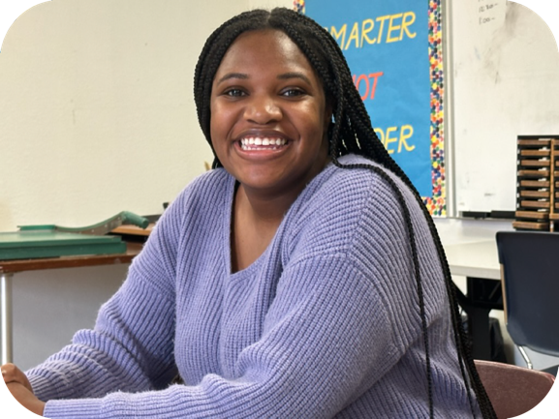 | “It is awesome to watch their eyes light up when they are successful in areas that they have not been successful in before. My students are now more confident in all areas of school. They build relationships, have fun, and learn.”

Aliyah Gillespie

Cahokia Penniman Elementary School, Cahokia CUSD 187

Region 5 – Southern Illinois University Edwardsville
“To have the opportunity to give back to the community and have the firsthand opportunity to experience working with the kids who’ll soon enough be the future of us, and our society is priceless. It’s refreshing to see actual, real-life initiatives help children grow and create a more exhilarating learning environment for everyone involved.” |  | 
Laraib Khan
Murphysboro Carruthers, Murphysboro CUSD 186
Region 5/6 – Southern Illinois University Carbondale
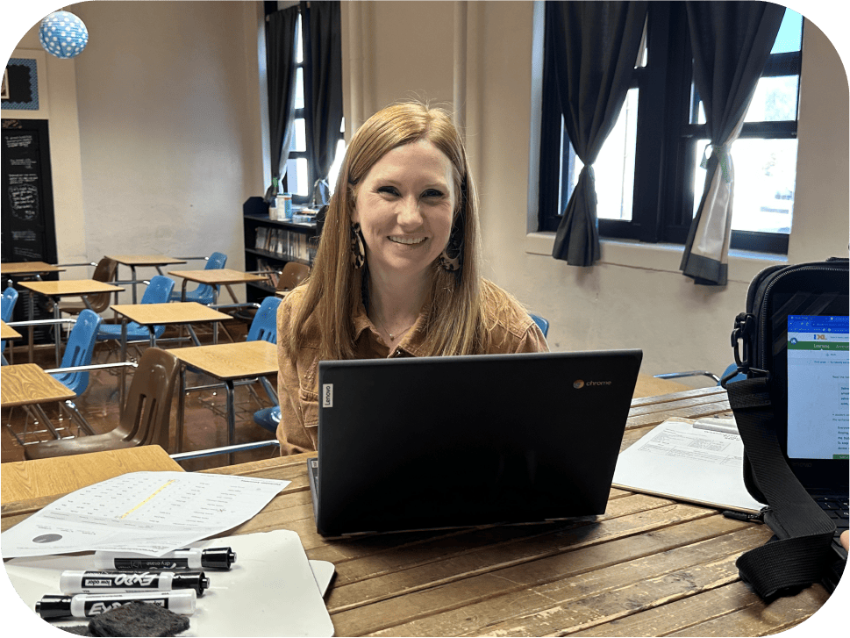 | “The best part of tutoring is the relationships I’ve been able to grow among my little group of students. We spend so much time together that we have our own inside jokes.”
Megan King
Washington Attendance Center, Carmi-White County CUSD 5
Region 6 – Southeastern Illinois College

Self-Efficacy, Training, and Fidelity
During AY24, tutors in the ITI were evaluated on multiple outcomes including self-efficacy, tutor training, fidelity of tutoring sessions, and reflection on individual tutoring sessions. Before being paired with students, prospective tutors completed a series of training modules designed to teach the principles and practices of high-impact tutoring, strategies for learner engagement, and methods for delivering culturally relevant tutoring. Their successful completion of these modules was confirmed through corresponding assessments.

Once tutoring sessions began, fidelity for high-impact tutoring practices was monitored through tutor self-reports and observations conducted by institutional partners. Additionally, tutor self-efficacy—defined as confidence in one’s ability to influence motivation, behavior, and the social environment—was measured at the start and end of the Spring 2024 semester, providing valuable insights into their growth and confidence over time.

Tutor Self-Efficacy
At the start and end of the Spring 2024 semester, tutors completed surveys assessing their self-efficacy in key areas: helping students think critically, evaluating student comprehension, and employing diverse instructional and assessment strategies. Results indicate that the tutor's sense of self-efficacy grew for several items, with paired sample results indicating statistically significant growth.

Table 4: Tutor Self-Efficacy Survey Questions and Mean Scores
INDEPENDENT SAMPLES

Survey Instructions: Please indicate your opinion about each of the statements below. | Start of Spring 2024 Semester  (N=736) | End of Spring 2024 Semester  (N=705)
How much can you do to get through to the most difficult students? | 4.1 | 4.2
How much can you do to help your students think critically? | 4.2 | 4.3
How much can you do to motivate students who show low interest in schoolwork? | 4.2 | 4.2
How well can you get students to believe they can do well in schoolwork? | 4.4 | 4.4
How well can you respond to difficult questions for your students? | 4.4 | 4.4
How much can you do to help your students value learning? | 4.2 | 4.3
How much can you gauge student comprehension of what you have taught? | 4.4 | 4.5
To what extent can you craft good questions for your students? | 4.4 | 4.4
How much can you do to foster student creativity? | 4.2 | 4.3
How much can you do to improve the understanding of a student who is failing? | 4.2 | 4.2
How much can you do to adjust your lessons to the proper level for individual students? | 4.5 | 4.5
How much can you use a variety of informal assessment strategies? | 4.3 | 4.4
To what extent can you provide an alternative explanation or an example when your students are confused? | 4.5 | 4.5
How much can you assist families in helping their children to do well in school? | 3.7 | 3.8
How well can you implement alternative strategies in your classroom? | 4.3 | 4.4
How well can you provide appropriate challenges for very capable students? | 4.4 | 4.4

Likert scale = 1-5 with 1=Nothing, 2=Very Little, 3=Some influence, 4=Quite a bit, and 5=A great deal
Table 5: Tutor Self-Efficacy Survey Questions and Results
PAIRED SAMPLES (N=575)

Survey Instructions: Please indicate your opinion about each of the statements below. | Start of Spring 2024 Semester  Mean & SD | End of Spring 2024 Semester  Mean & SD | t-value | p-value | Effect size
How much can you do to get through to the most difficult students? | 4.13 (0.70) | 4.19 (0.66) | t=-2.24 | p=0.026* | .093
How much can you do to help your students think critically? | 4.22 (0.68) | 4.26 (0.62) | t=-1.40 | p=0.163 | .058
How much can you do to motivate students who show low interest in schoolwork? | 4.14 (0.72) | 4.17 (0.72) | t=-1.03 | p=0.305 | .043
How well can you get students to believe they can do well in schoolwork? | 4.40 (0.64) | 4.40 (0.64) | t=-0.12 | p=0.901 | .005
How well can you respond to difficult questions for your students? | 4.39 (0.63) | 4.46 (0.61) | t=-2.54 | p=0.011* | .106
How much can you do to help your students value learning? | 4.20 (0.71) | 4.24 (0.71) | t=-1.23 | p=0.220 | .051
How much can you gauge student comprehension of what you have taught? | 4.42 (0.61) | 4.49 (0.58) | t=-2.74 | p=0.006** | .114
To what extent can you craft good questions for your students? | 4.40 (0.61) | 4.46 (0.59) | t=-2.24 | p=0.026* | .093
How much can you do to foster student creativity? | 4.19 (0.72) | 4.27 (0.70) | t=-2.56 | p=0.011* | .107
How much can you do to improve the understanding of a student who is failing? | 4.18 (0.69) | 4.22 (0.66) | t=-1.44 | p=0.150 | .060
How much can you do to adjust your lessons to the proper level for individual students? | 4.48 (0.63) | 4.54 (0.57) | t=-2.20 | p=0.028* | .092
How much can you use a variety of informal assessment strategies? | 4.29 (0.69) | 4.39 (0.64) | t=-3.52 | p=<.001*** | .147
To what extent can you provide an alternative explanation or an example when your students are confused? | 4.50 (0.56) | 4.55 (0.56) | t=-2.06 | p=0.040* | .086
How much can you assist families in helping their children to do well in school? | 3.66 (0.91) | 3.77 (0.97) | t=-2.79 | p=0.006** | .116
How well can you implement alternative strategies in your classroom? | 4.29 (0.70) | 4.35 (0.70) | t=-2.22 | p=0.027* | .093
How well can you provide appropriate challenges for very capable students? | 4.45 (0.62) | 4.45 (0.61) | t=0.00 | p=1.000 | .000

Likert scale = 1-5 with 1=Nothing, 2=Very Little, 3=Some influence, 4=Quite a bit, and 5=A great deal
* p<.05 ** p<.01 *** p<.001

Cohen’s effect size interpretation:
Small effect: 0.01 - 0.2
Medium effect: 0.2 - 0.5
Large effect: 0.5 - 0.8
Very Large effect: 0.8 - 1.2

Tutor Training

All tutors were trained using core modules prior to being matched with students to tutor. In addition, they were required to complete content specific modules. Each module included a quiz requiring a minimum score of 80%, with tutors retaking the quizzes as needed to achieve this benchmark. The graphs below indicate average scores across all trained tutors on core and content modules.

Figure 19: Core Training Modules

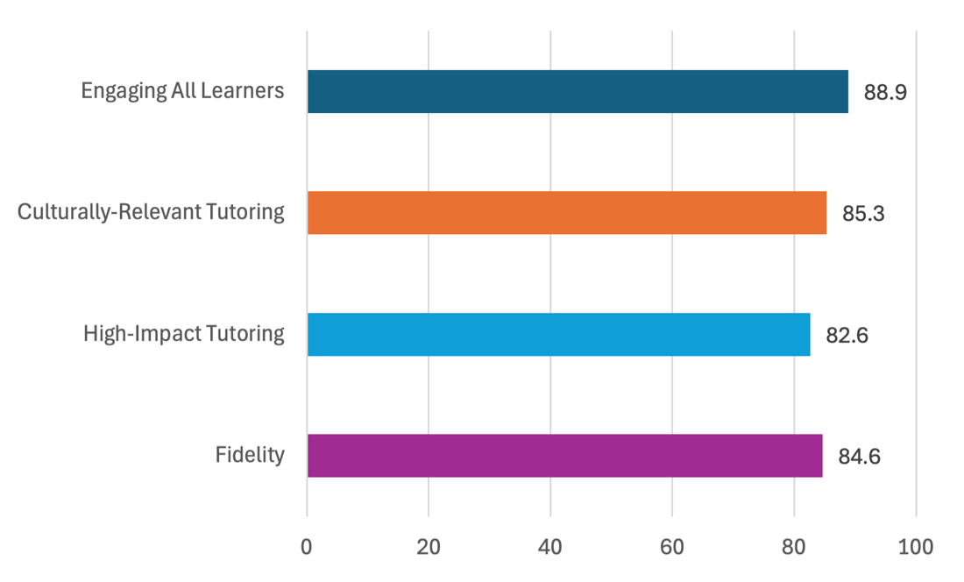

Figure 20: Content Training Modules

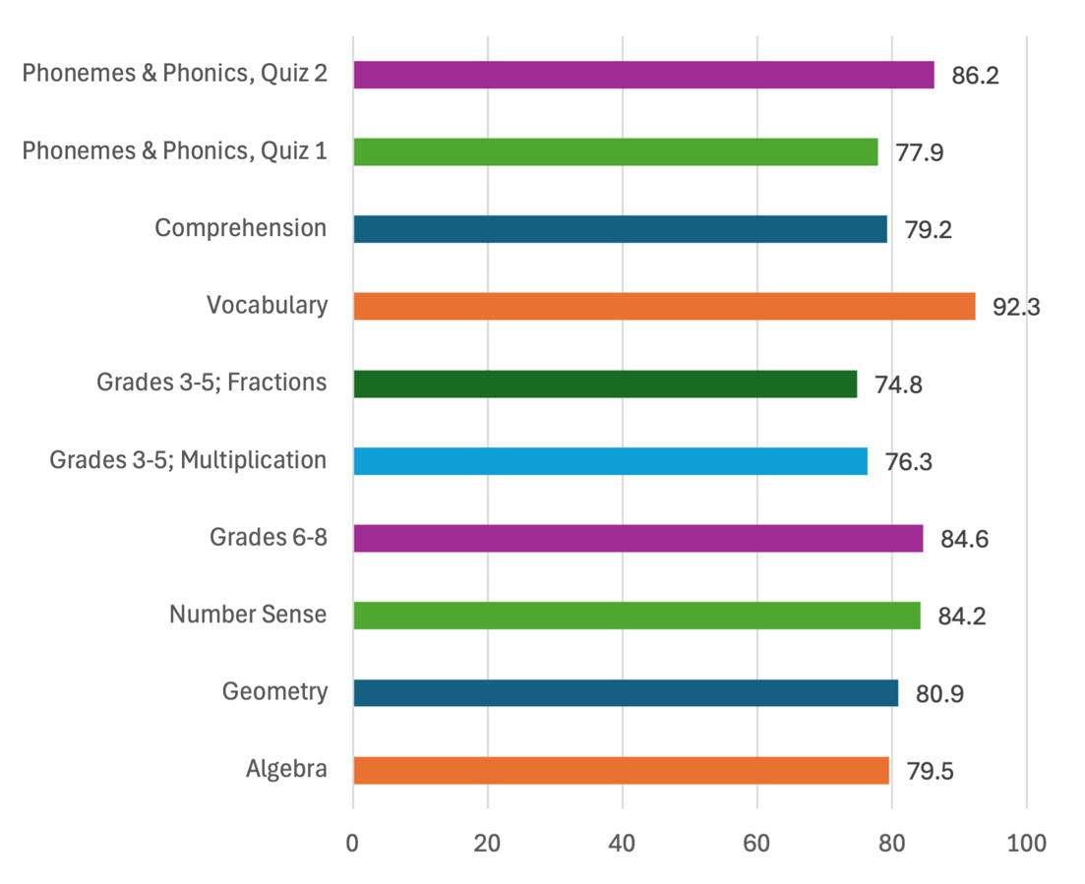

Tutor Fidelity

Tutors were trained in how to conduct a high-impact tutoring session. At the end of each session, all tutors self-report which steps they completed during the session. Additionally, tutor supervisors conduct periodic observations of tutors within their region to guide tutor coaching and supports. AY24 results indicate tutors consistently delivering tutoring sessions as trained and containing all components.

Table 6: Self-Reported vs. Observed Fidelity of Tutoring Session

Aspect of Tutoring Session | Fall 2023 |  | Spring 2024 |  | Summer 2024
Aspect of Tutoring Session | Self-report %  (N=26,546) | Observed %  (N=348) | Self-report %  (N=45,825) | Observed %  (N=630) | Self-report %  (N=14,881) | Observed %  (N=273)
Relationship Building | 99.8 | 99.4 | 99.9 | 98.8 | 99.8 | 99.3
positive communication | 93.6 | 92.9 | 94.5 | 91.1 | 93.2 | 84.7
expressing empathy | 66.5 | 73.7 | 71.5 | 52.5 | 70.6 | 44.0
providing honest feedback | 72.9 | 79.43 | 76.8 | 77.9 | 77.9 | 57.5
Reviewed the previous session | 90.8 | 88.9 | 92.5 | 60.3 | 90.9 | 66.2
Introduced topic or focus | 97.2 | 97.1 | 97.5 | 92.8 | 98.1 | 92.0
set learning goals | 95.1 | 88.9 | 95.9 | 78.5 | 97.2 | 89.1
Used explicit instruction | 94.5 | 92.3 | 95.4 | 71.2 | 96.7 | 85.8
Used Guided Practices | 96.9 | 99.1 | 97.7 | 98.3 | 98.1 | 99.3
providing relevant new tasks | 65.9 | 75.7 | 69.9 | 69.8 | 72.4 | 59.6
prompting students as needed | 83.4 | 93.4 | 86.1 | 93.0 | 85.2 | 74.6
providing explanations if students ask questions | 81.3 | 86.6 | 84.1 | 78.1 | 84.1 | 78.9
Used Deliberate Practices | 97.2 | 97.1 | 98.0 | 93.0 | 97.8 | 93.1
providing study material | 60.8 | 71.7 | 63.8 | 58.8 | 64.6 | 29.1
observing the student practice | 82.7 | 92.9 | 85.6 | 87.5 | 84.4 | 78.2
providing prompts or demonstrations as needed | 85.1 | 86.3 | 87.3 | 74.0 | 84.7 | 69.5
Checked for student understanding | 99.1 | 99.4 | 99.4 | 98.3 | 99.3 | 98.6

*Self-reported surveys were completed at the end of each session by tutors, therefore there are multiple surveys for each tutor. Observed surveys were completed by tutor supervisors on randomly selected tutors. Some tutors were observed more than once.
Tutor Session Feedback

At the conclusion of each tutoring session, tutors completed a short feedback survey. Results across all tutors across all sessions are reported below. Tutors indicated consistently high engagement, enjoyment, and learning.

Table 7: Tutor Feedback

Question | Fall 2023  (N=49,957) |  | Spring 2024  (N=82,032) |  | Summer 2024  (N=21,535)
Question | Percent* | Average Score | Percent* | Average Score | Percent* | Average Score
How engaged was the student this session? | 91.5 | 4.5 | 93.1 | 4.6 | 95.2 | 4.7
How much did you enjoy this session? | 94.0 | 4.6 | 94.8 | 4.6 | 96.7 | 4.7
How much do you think the student learned this session? | 85.6 | 4.3 | 88.9 | 4.4 | 91.0 | 4.5
Overall, how did this tutoring session go? | 93.2 | 4.6 | 94.4 | 4.6 | 96.6 | 4.7

*Percentage of surveys with positive response (4 or 5 on a 5-point Likert scale).
Likert scale = 1-5 with scales differing by question

 | Engagement | Enjoyment | Learning | Overall
1 | Not engaged at all | Did not enjoy at all | Almost nothing | Not well at all
2 | A little engaged | Enjoyed a little bit | A little bit | Slightly well
3 | Somewhat engaged | Enjoyed somewhat | Some | Somewhat well
4 | Quite engaged | Enjoyed quite a bit | Quite a bit | Quite well
5 | Extremely engaged | Enjoyed a tremendous amount | A tremendous amount | Extremely well

Tutor Demographics

Tutors were employed throughout the state and varied by age, educational levels, and student status.

Figure 21: Tutors by Region

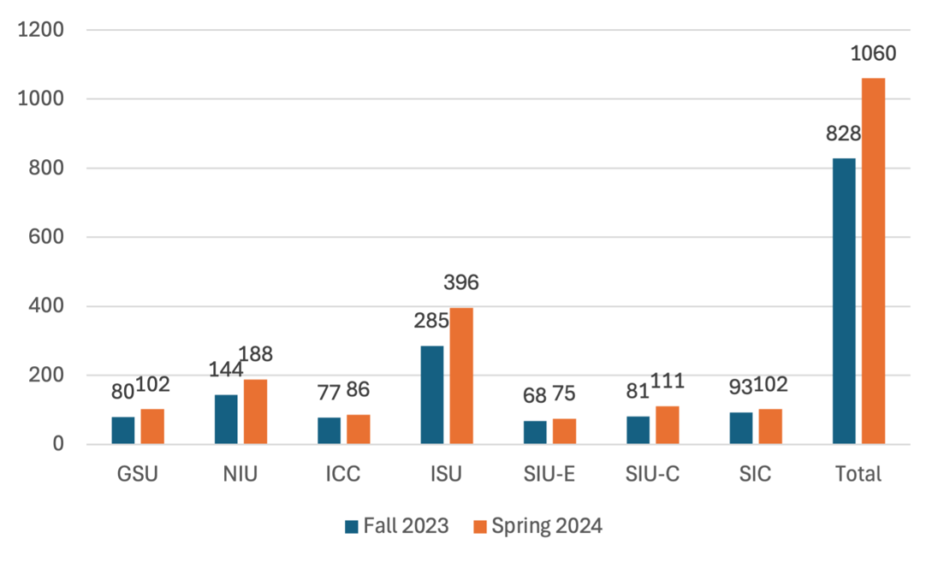
1,141 unique tutors

Figure 22: Tutors by Highest Degree

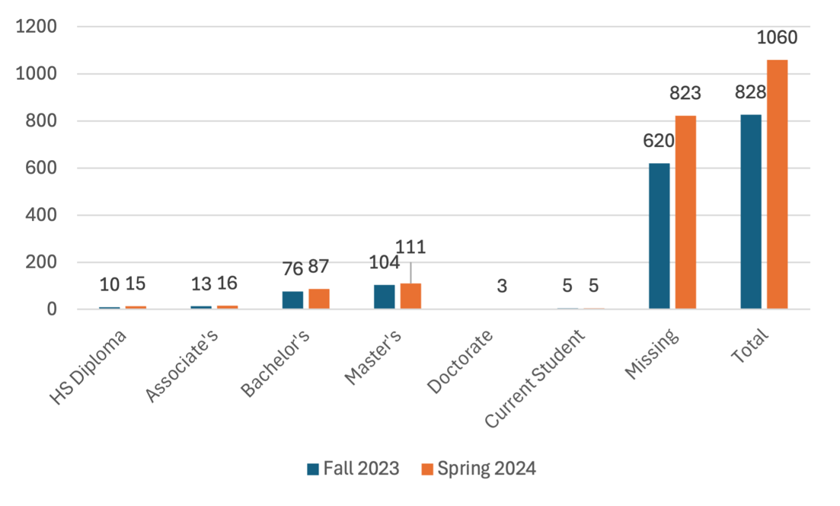
1,141 unique tutors
*three of the five current students were education majors

Figure 23: Tutors by Ethnicity

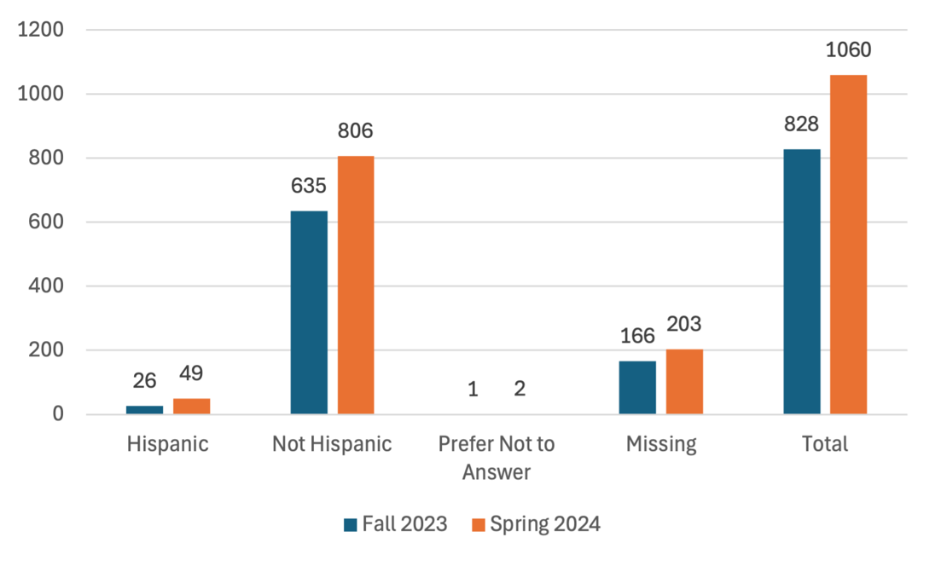
1,141 unique tutors

Figure 24: Tutors by Race

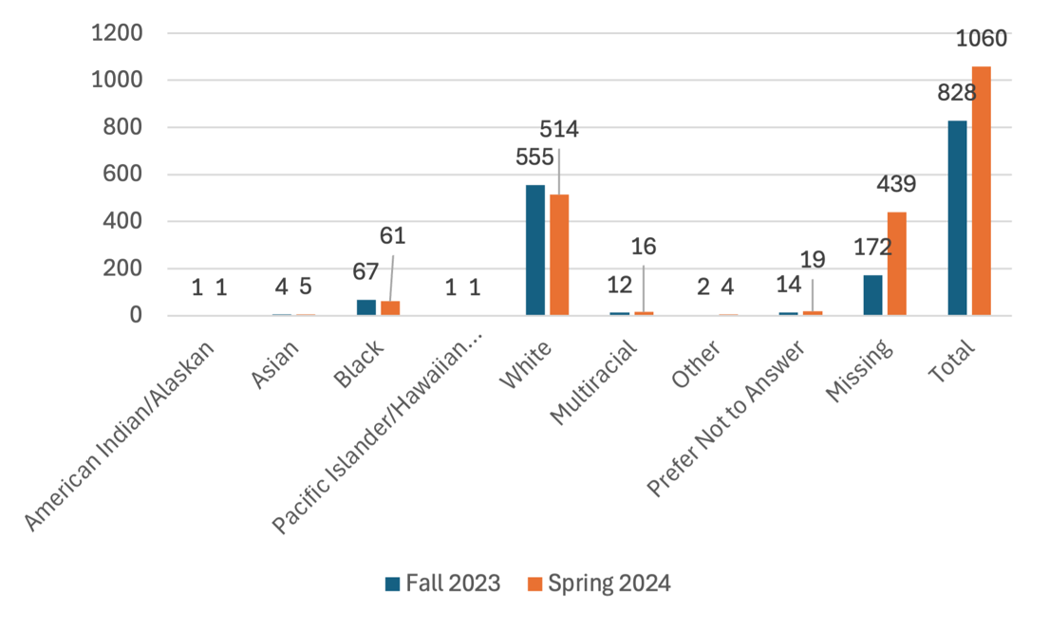
1,141 unique tutors

Figure 25: Tutors by Age

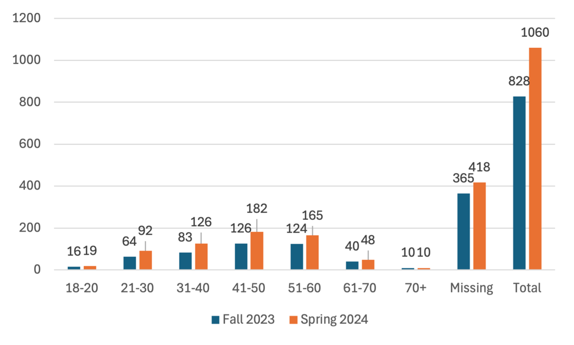
1,141 unique tutors

Tutor Languages Spoken

English Russian French Arabic Swahili Macedonian Spanish Hindi

Institutional and District Partners

 | “It is the best thing that could have happened to our school system in the State of Illinois, and it needs to continue so we have an opportunity to gather substantial data and see real change.”

Jeanetta Edward

Governors State University
“I see the students progressing through progress monitoring and through simple observation. Students can go to the whiteboard to explain their work with words and with strategies and pictures. The students are feeling more confident in using different types of strategies to come up with answers.” |  | 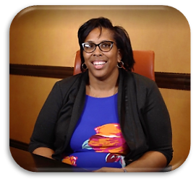

Melissa Sago, Principal and Tutor

Lincoln Douglas, Freeport 145

Region 2 – Northern Illinois University
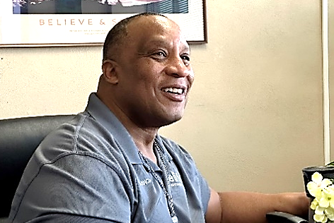 | “At Elite Community Outreach, we serve the most marginalized students who are on the cusp of dropping out of school. The ITI is a difference maker at our center. Because most of our tutors are close in age to our students and come from similar backgrounds, it makes it cool for our students to learn again. A role model working with them every day is closing the gap. Our data shows that major disciplinary referrals dropped 85% this year, and 75% of our student population improved both their reading and math scores. The ITI is definitely working for our kids.”
Carl Cannon
Elite Community Outreach, Peoria District 150
Region 3 – Illinois Central College
“We definitely see progress in the students from the ITI. Students are enjoying the time they're getting with staff. We use all our staff as tutors in our district. We are seeing the kids who are doing after school tutoring increasing their progress at a much higher rate. There are many positive gains.” |  | 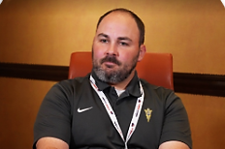

Bobby Beck, Elementary Principal

Villa Grove 302

Region 4 – Illinois State University
 | “The Illinois Tutoring Initiative has been a great benefit to the students at Penniman Elementary. We have seen an increase in student's test scores and confidence. The tutors are professional and engage students in fun meaningful ways that help them learn best. I look forward to continuing the partnership with the Illinois Tutoring Initiative.”

Tamyra Taylor, Principal

Penniman Elementary, Cahokia Heights

Region 5 – Southern Illinois University Edwardsville
“I am a school social worker and I deal with more of the emotional, social, and behavior side of students, not academics. Becoming a tutor feels natural to me. It has made me a better person. My eyes are more opened to students as a whole. I now understand that they need me as much as I need them. I look forward to going after my work day.” |  | 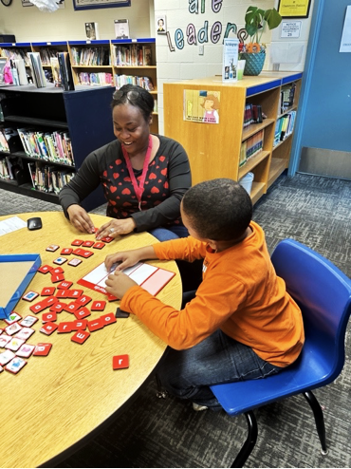

Juanita Drue

Lewis Elementary Carbondale 95

Region 5/6 – Southern Illinois University Carbondale
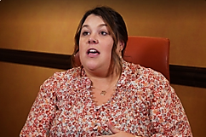 | “My teachers tell me all the time that my students are doing really well in class right now. They've improved so much. This is awesome! I think it's really great for them. Students are also improving in the classroom socially. The kids look forward to it everyday.”

Morgan Nelson, District Coordinator

Grayville Community District No. 1

Region 6 – Southeastern Illinois College

Priority school districts were identified based on level of funding using the evidence-based funding formula, concentration of low-income students, and disproportionate COVID-19 impact. Table 6 shows priority districts and schools served by each institutional partner for fall 2023 and spring and summer 2024. In total, the ITI partnered with 69 districts and 152 school sites in AY24.

Table 6: Priority Districts and Schools Served Academic Year 2023-24

Region 1 – Governors State University
Districts Served | F | S | SU | Schools by District | F | S | SU
Hoover-Schrum 157 | X | X |  | Hoover Elementary | X | X
Prairie Hills 144 | X | X |  | Prairie Hills Junior High |  | X
 |  |  |  | Nob Hill Elementary | X
Union Ridge 86 | X | X | X | Union Ridge Elementary | X | X | X
Park Forest 163 | X | X |  | 21st Century | X | X
 |  |  |  | Blackhawk Elementary | X | X
 |  |  |  | Mohawk Elementary | X | X
 | X | X |  | Barack Obama School of Leadership and STEM | X | X
Burnham 154-5 | X | X | X | Burnham Elementary | X | X | X
CCSD 168 | X | X | X | Strassburg Elementary | X | X | X
 |  |  |  | Rickover Jr. High | X | X | X
Harvey School District 152 |  | X | X | Maya Angelou Elementary |  | X | X
North Chicago District 187 | X | X |  | Katzenmaier Elementary School | X | X
Crete Monee SD #201U | X | X |  | Balmoral Elementary | X | X
 |  |  |  | Crete Elementary | X | X
 |  |  |  | Crete Monee Middle School | X | X
 |  |  |  | Monee Elementary | X | X
 |  |  |  | Coretta Scott King Magnet | X | X
 |  |  |  | Talala Elementary | X | X
Total: | 8 | 9 | 4 |  | 17 | 18 | 5

Region 2 – Northern Illinois University
Districts Served | F | S | SU | Schools by District | F | S | SU
Rochelle CCSD 231 | X | X | X | Rochelle Middle School | X | X | X
Hiawatha CUSD 426 | X | X | X | Hiawatha Elementary | X | X | X
 |  |  |  | Hiawatha Jr/Sr High School | X | X
Colona SD 190 | X | X |  | Colona Grade School | X | X
North Boone CUSD 200 | X | X |  | Manchester Elementary | X | X
 |  |  |  | North Boone Upper Elementary | X | X
Oglesby ESD 125 | X | X | X | Lincoln Elementary | X | X | X
 |  |  |  | Washington Junior High | X | X
DeKalb 428 | X | X |  | Lincoln Elementary | X | X
 |  |  |  | Cortland Grade School | X | X
 |  |  |  | Jefferson Elementary | X | X
 | X | X |  | Tyler Elementary | X | X
Freeport 145 | X | X | X | Carl Sandburg Middle School | X | X | X
 |  |  |  | Lincoln Douglas Elementary | X | X | X
Rockford 205 | X | X | X | West Middle School | X | X | X
Rock Island-Milan SD 41 | X | X | X | Rock Island Academy | X | X | X
Spring Valley CCSD 99 | X | X | X | John F. Kennedy Elementary | X | X | X
U-46 |  |  | X | Century Oaks Elementary School | X | X
U-46 | X | X | X | Heritage Elementary School | X | X | X
U-46 |  |  | X | Lords Park Elementary School |  | X
Total: | 11 | 11 | 8 |  | 19 | 20 | 9

Region 3 – Illinois Central College
Districts Served | F | S | SU | Schools by District | F | S | SU
Riverton 14 | X | X | X | Riverton Elementary | X | X | X
 |  |  |  | Riverton Middle School | X | X
Illinois Valley Central | X |  | X | Chillicothe Elementary Center | X | X
Illinois Valley Central | X |  | X | Chillicothe Junior High | X | X
Illinois Valley Central | X | X | X | Mossville Junior High | X | X
Illinois Valley Central | X |  | X | Mossville Elementary | X | X
Illinois Valley Central | X |  | X | South Elementary | X | X | X
N. Pekin/Marquette Heights 102 | X | X |  | Marquette Elementary | X | X
Peoria 150 | X | X | X | Annie Jo Gordan | X | X | X
 |  |  |  | Elise-Ford Allen Academy | X | X
 |  |  |  | Elite Community Outreach | X | X | X
 |  |  |  | Glen Oak Community Learning | X | X
 |  |  |  | Harold B. Dawson Middle | X | X
 |  |  |  | Hines Primary School | X | X
 |  |  |  | Lincoln K-8 School | X | X
 |  |  |  | Dr. Maude A. Sanders Primary | X | X
 |  |  |  | Trewyn Middle School | X | X
 |  |  |  | Franklin Primary | X | X
 |  |  |  | Von Steuben Middle School | X | X
 |  |  |  | Sterling Middle School | X | X
Norwood 63 | X | X |  | Norwood Elementary | X | X
Pleasant Hill CUSD 69 | X | X | X | Pleasant Hill School | X | X | X
Macomb CUSD 185 |  | X |  | Edison School |  | X
Riverview 2 | X | X |  | Riverview Grade School | X | X
Total: | 7 | 8 | 4 |  | 23 | 24 | 5

Region 4 – Illinois State University
Districts Served | F | S | SU | Schools by District | F | S | SU
Donovan CUSD 3 | X | X | X | Donovan Junior High | X | X | X
 |  |  |  | Donovan Elementary | X | X | X
Paris-Union 95 | X | X | X | Mayo Middle School | X | X | X
 |  |  |  | Carolyn Wenz Elementary School | X | X | X
Paris CUSD 4 | X | X | X | Crestwood Elementary | X | X | X
Mattoon CUSD 2 | X | X | X | Riddle Elementary School | X | X
 |  |  |  | Arland D. Williams Elementary | X | X | X
Martinsville 3 | X | X | X | Martinsville Elementary | X | X | X
 |  |  |  | Martinsville Junior Senior High | X | X | X
Rantoul City SD 137 | X | X | X | Broadmeadow Elementary | X | X | X
 |  |  |  | Eastlawn Elementary |  | X
 |  |  |  | Northview Elementary | X | X | X
 |  |  |  | Pleasant Acres Elementary | X | X
Clinton CUSD 15 | X | X | X | Clinton Elementary | X | X | X
 |  |  |  | Clinton Junior High | X | X
Kansas CUSD 3 | X | X | X | Kansas Elementary | X | X | X
 |  |  |  | Kansas Junior High |  | X
Lexington CUSD 7 |  | X |  | Lexington Elementary |  | X
Villa Grove 302 | X | X | X | Villa Grove Elementary | X | X | X
Shiloh CUSD 1 | X | X | X | Shiloh Elementary | X | X | X
 |  |  |  | Shiloh Junior High | X | X | X
Saunemin 438 | X | X | X | Saunemin Elementary | X | X | X
Decatur 61 | X | X | X | Hope Academy | X | X
 |  |  |  | American Dreamer STEM Academy | X | X
 |  |  |  | James B. Parsons Elementary | X | X
 |  |  |  | Johns Hill Magnet School |  |  | X
 |  |  |  | E. J. Muffley Elementary School | X | X
 |  |  |  | South Shores Elementary | X | X
 |  |  |  | Michael E. Baum Elementary | X | X
 |  |  |  | Franklin Grove Elementary | X | X
 |  |  |  | Dennis Lab School |  | X
 |  |  |  | Montessori Academy for Peace | X | X
 |  |  |  | MacArthur High School |  |  | X
Georgetown-Ridge Farm CUSD 4 |  |  | X | Mary Miller Junior High |  |  | X
Georgetown-Ridge Farm CUSD 4 |  |  | X | Pine Crest Elementary |  |  | X
McLean County Unit School District 5 | X | X |  | Cedar Ridge Elementary | X | X
 |  |  |  | Fairview Elementary | X | X
 |  |  |  | Oakdale Elementary | X | X
 |  |  |  | Sugar Creek Elementary | X | X
Pontiac 429 | X | X | X | Lincoln Elementary | X | X | X
 |  |  |  | Washington Elementary | X | X | X
 |  |  |  | Pontiac Junior High | X | X
Bloomington Public Schools District 87 | X | X |  | Bloomington Junior High School | X | X
Champaign CUSD 4 |  | X | X | Edison Middle School |  | X | X
Champaign CUSD 4 |  | X | X | Franklin STEAM Academy |  | X
Champaign CUSD 4 |  | X | X | Jefferson Middle School |  | X
Champaign CUSD 4 |  | X | X | Stratton Academy of the Arts |  | X
Tuscola CUSD #301 | X | X | X | North Ward Elementary | X | X | X
 |  |  |  | East Prairie Junior High | X | X | X
Total: | 16 | 18 | 16 |  | 37 | 45 | 25

Region 5 – Southern Illinois University Edwardsville
Districts Served | F | S | SU | Schools by District | F | S | SU
Collinsville 10 | X | X | X | Dorris Intermediate | X | X
 |  |  |  | Twin Echo Elementary | X | X
 |  |  |  | Kreitner Elementary | X | X
 |  |  |  | Jefferson Elementary | X | X
 |  |  |  | Webster Elementary |  |  | X
 |  |  |  | Renfro Elementary | X | X
Cahokia 187 | X | X | X | Penniman Elementary | X | X
 |  |  |  | Huffman Elementary | X | X | X
 |  |  |  | Lalumier Elementary | X | X
 |  |  |  | Maplewood Elementary |  |  | X
East Alton SD 13 | X | X | X | Eastwood Elementary | X | X | X
 |  |  |  | East Alton Middle School |  | X
Dupo Community School District 196 | X | X | X | Dupo Junior High | X | X | X
Madison CUSD 12 | X | X | X | Bernard Long Elementary | X | X | X
 |  |  |  | Madison Junior High |  |  | X
East St. Louis District 189 | X | X | X | Lincoln Middle School | X | X
 |  |  |  | Mason-Clark Middle School | X | X | X
 |  |  |  | Wyvetter Younge School of Excellence | X | X
 | X | X | X | Annette Officer Elementary |  |  | X
Total: | 6 | 6 | 6 |  | 14 | 15 | 9

Region 5/6 – Southern Illinois University Carbondale
Districts Served | F | S | SU | Schools by District | F | S | SU
Carbondale District 95 | X | X | X | Carbondale Middle School | X | X | X
 |  |  |  | Lewis Elementary | X | X | X
 |  |  |  | Thomas Elementary | X | X | X
Cobden District 17 | X | X | X | Cobden Elementary | X | X | X
Meridian CUSD 101 | X | X | X | Meridian Elementary | X | X | X
Murphysboro 186 | X | X | X | Murphysboro Middle School | X | X | X
 |  |  |  | Carruthers Elementary School | X | X | X
Giant City District 130 | X | X | X | Giant City Elementary | X | X | X
 |  |  |  | Giant City Middle School | X | X
Herrin Community District 4 | X | X | X | Herrin Community Elementary | X | X | X
 |  |  |  | Herrin Junior High | X | X | X
Unity Point District 140 | X | X | X | Unity Point Elementary | X | X | X
Total: | 7 | 7 | 7 |  | 13 | 13 | 12

Region 6 – Southeastern Illinois College
Districts Served | F | S | SU | Schools by District | F | S | SU
Harrisburg 3 | X | X | X | East Side Intermediate | X | X | X
Anna 37 | X | X | X | Anna Junior High School | X | X | X
 |  |  |  | Davie Elementary School | X | X | X
Carmi-White 5 | X | X | X | Washington Attendance Center | X | X | X
 |  |  |  | Jefferson Attendance Center | X | X | X
 |  |  |  | Carmi-White County Junior High | X | X | X
Jonesboro CCSD 43 | X | X | X | Jonesboro Elementary | X | X | X
Grayville 1 | X | X | X | Wells Elementary School | X | X | X
 |  |  |  | Grayville Junior/Senior High | X | X | X
Galatia 1 | X | X |  | Galatia Grade School | X | X
Norris City-Omaha-Enfield CUSD 3 | X | X | X | Norris City-Omaha Elementary | X | X | X
Eldorado CUSD 4 |  | X | X | Eldorado Elementary |  | X | X
Carrier Mills-Stonefort CUSD #2 | X | X |  | Carrier Mills-Stonefort Elementary | X | X
Total: | 8 | 9 | 7 |  | 12 | 13 | 11

High School Online Math
Districts Served | F | S | SU | Schools by District | F | S | SU
Shiloh CUSD 1 | X | X | X | Shiloh High School | X | X | X
Donovan CUSD 3 | X | X |  | Donovan Senior High School | X | X
Martinsville CUSD 3C |  | X |  | Martinsville Junior Senior High School |  | X
Anna-Jonesboro CHSD 81** |  | X | X | Anna-Jonesboro Community High School |  | X | X
Total: | 2 | 4 | 2 |  | 2 | 4 | 2

Grand Total: | 63 | 69 | 52 |  | 137 | 152 | 78

*F=fall 2023, S=spring 2024, SU=summer 2024
**Only High School district counted in Grand Total – did not provide grade 3-8 tutoring

Tutoring Sessions

The ITI continued to scale across AY24 in both the number of priority districts and schools served. Over the course of the initiative, scaling increased drastically, resulting in over three times as many sessions being delivered in AY24 compared to AY22.

Figure 26: Sessions Delivered by Region

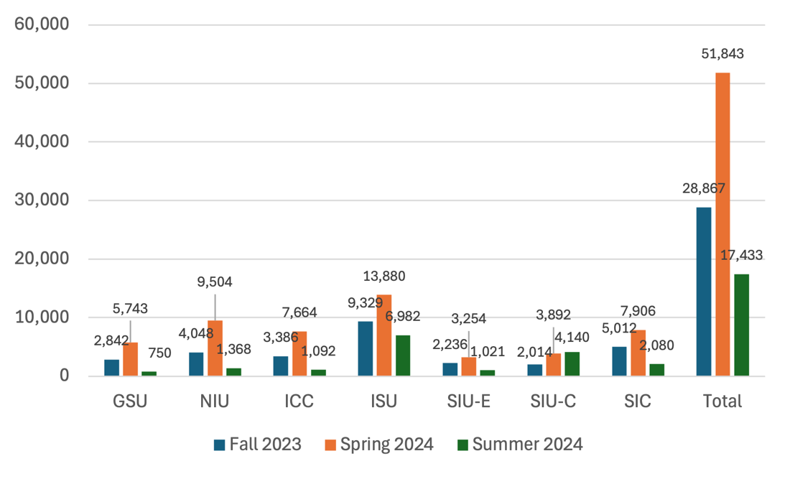

Figure 27: Tutoring Sessions AY22-AY24
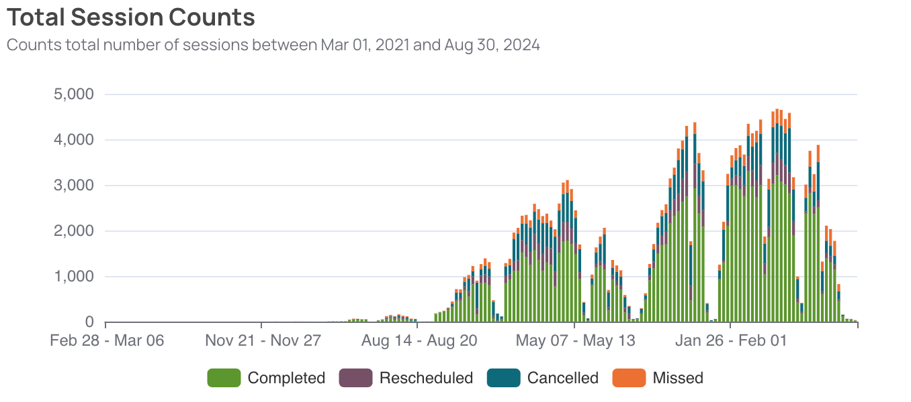

Figure 28: Tutoring Sessions AY24

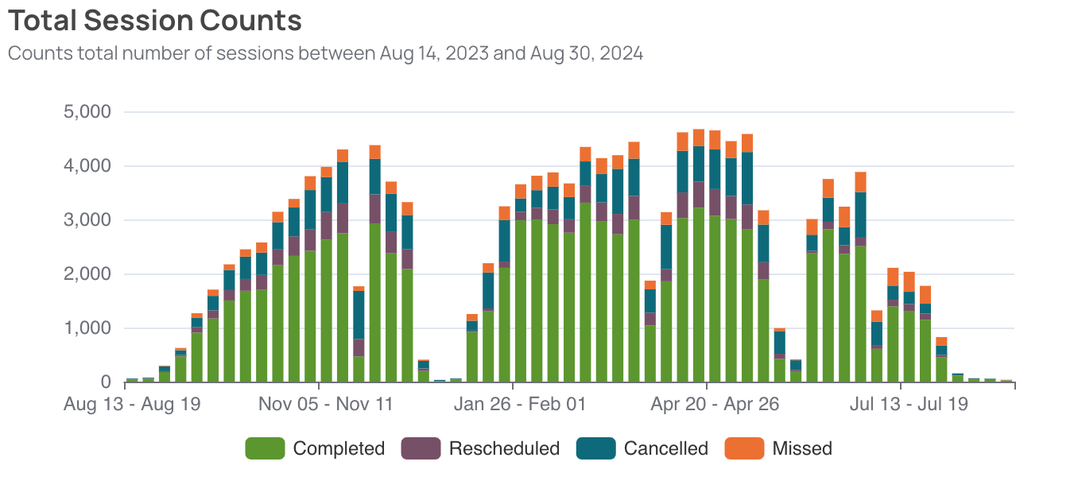

High School Math Tutoring

High school math tutoring was provided from Spring 2023 through Summer 2024. Tutoring was provided online until Spring 2024. At this time, tutoring was offered in the format selected by the district (online and/or face-to-face). Districts recommended students for tutoring in multiple math-related subjects, with the large majority of students receiving tutoring in Algebra 1, Geometry, and Algebra 2.

Student Demographics

High school students were served across grades, subjects, income levels, and ability levels. The largest concentration of high school math tutoring occurred in pre-algebra/algebra 1 for 9th and 10th graders.

Figure 29: High School Tutored Students by Grade

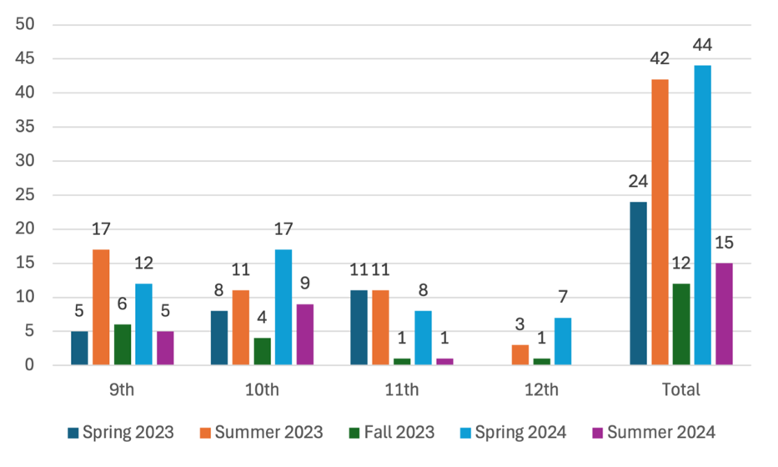
104 unique students tutored

Figure 30: High School Tutored Students by Subject

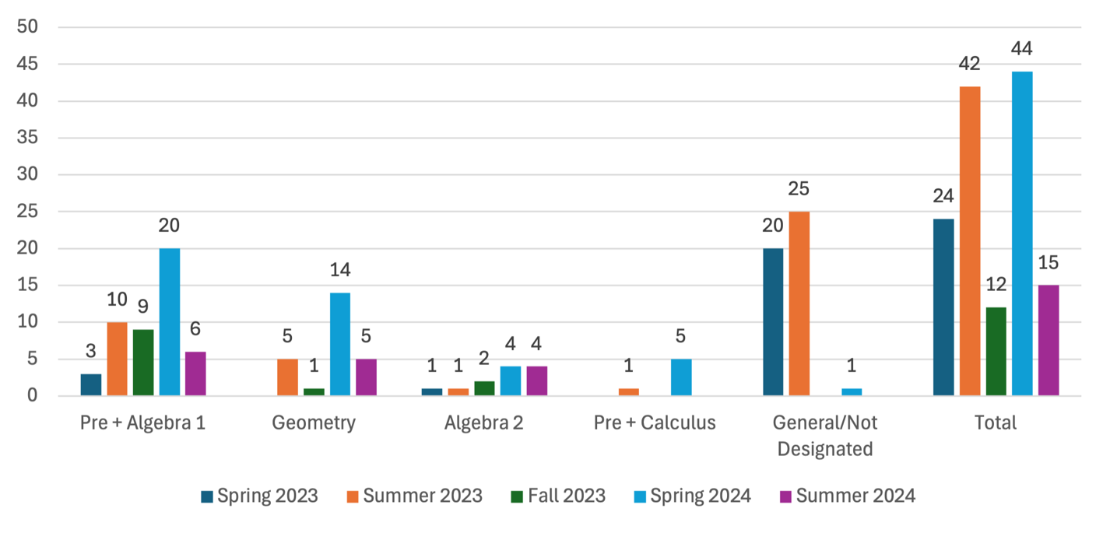
104 unique students tutored

Figure 31: High School Tutored Students by Race
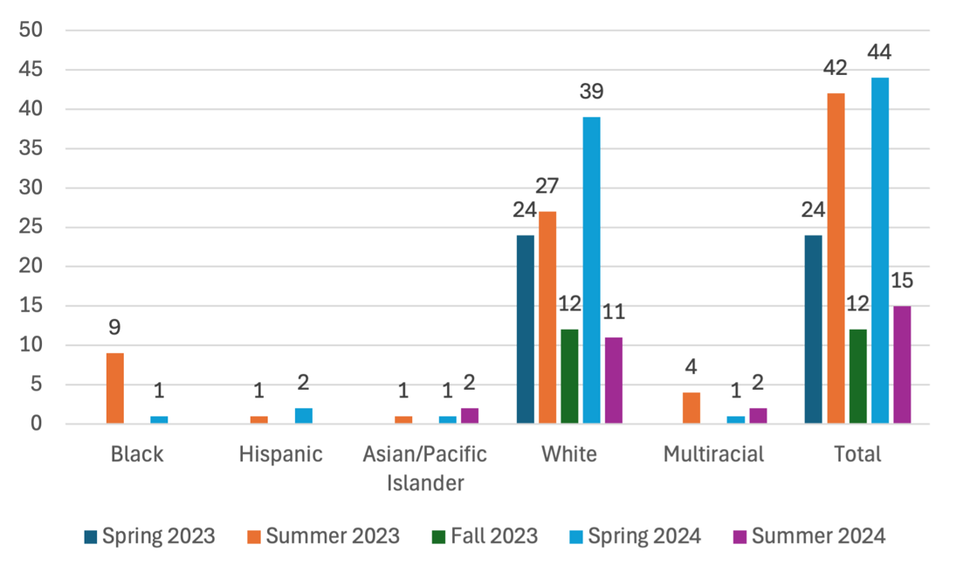
104 unique students tutored

Figure 32: High School Tutored Students by Special Education (SED) Status
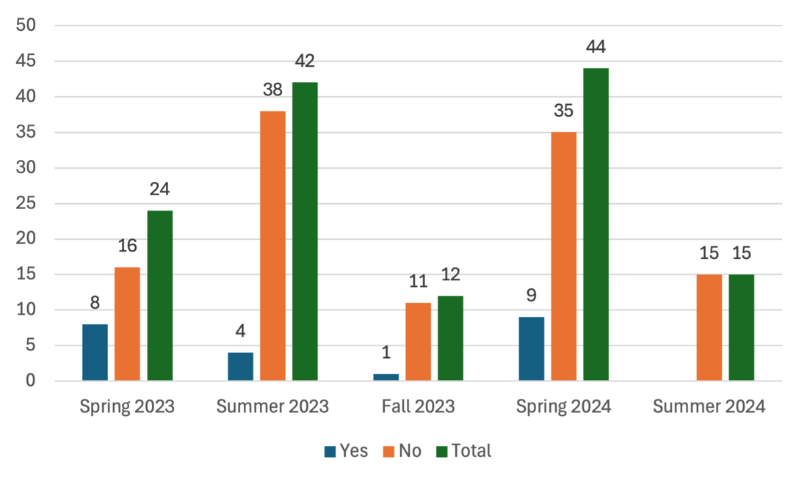
104 unique students tutored

Figure 33: High School Tutored Students by Low-Income Status
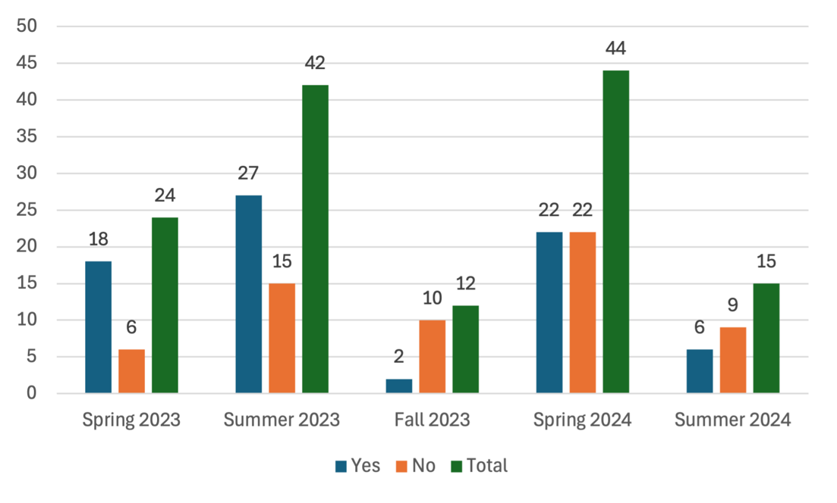
104 unique students tutored

ELL Status – 100% of tutored high school math students did not have English Language Learner (ELL) Status

Student Growth

High school student grades were tracked by quarter and semester. Nearly 60% of tutored students had their quarterly math grades sustain or improve in Fall 2023 and nearly 80% in Spring 2024. Semester grades were noted to improve for approximately 80% of tutored students with data.

Figure 34: High School Students with Growth in Quarterly Math Grade - Number
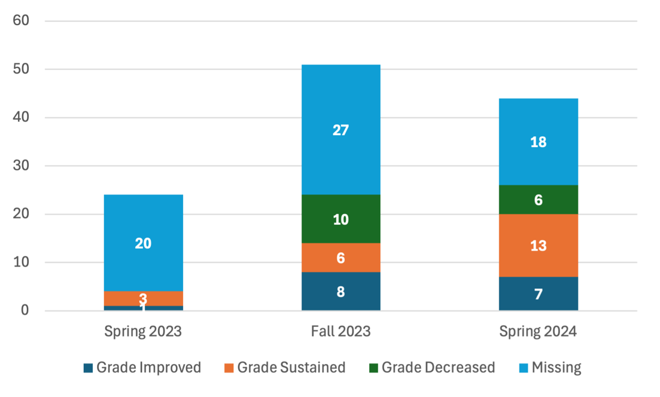

Figure 35: High School Students with Growth in Quarterly Math Grade - Percent

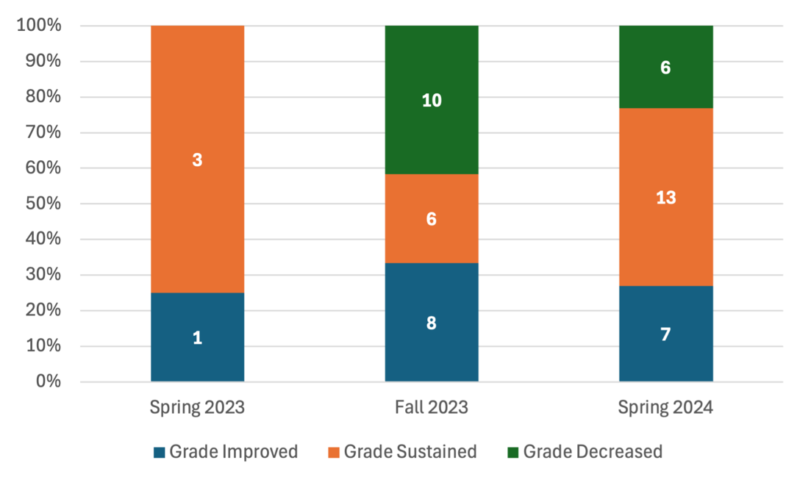

Figure 36: High School Students with Growth in Semester Math Grade - Number
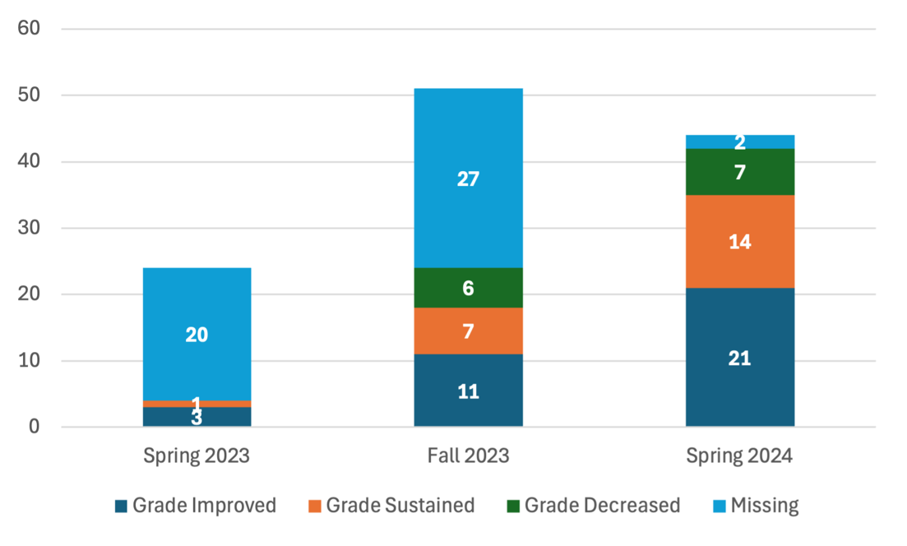

Figure 37: High School Students with Growth in Semester Math Grade - Percent
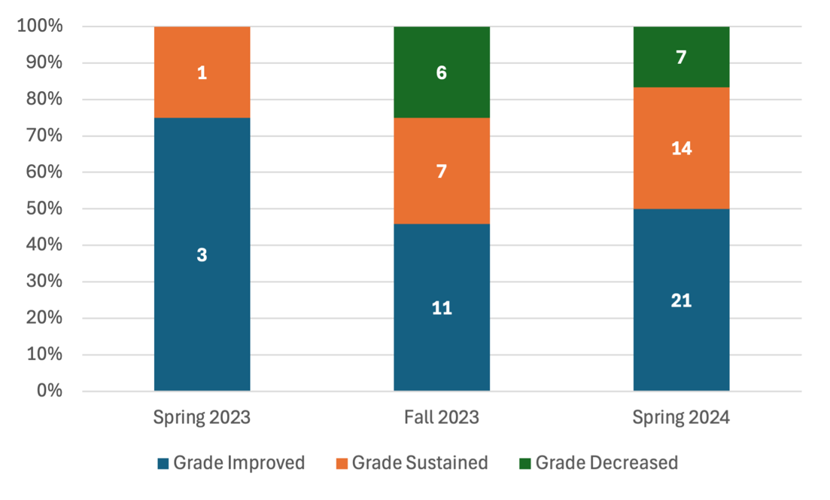
Increased Semester Grades – Impact

Those students with increased semester grades were further examined to determine the impact of tutoring. While the sample size is small, the impact is large for these students, with large percentages raising their grades from failing to passing and an even larger percentage increasing their grades by 1 letter grade or more.

Figure 38: High School Student Growth Impact - Percent
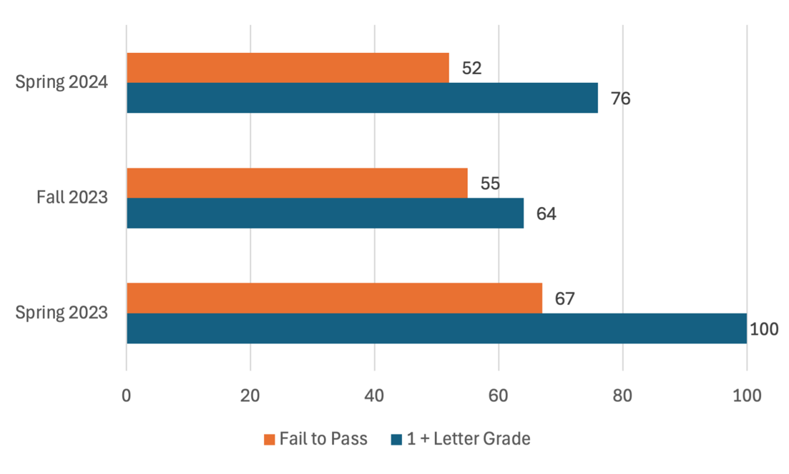

Session Feedback - Students

At the conclusion of each tutoring session, students completed a short feedback survey. Results across all students across all sessions are reported below. Students reported consistently high confidence in understanding the material, enjoyment, and learning.

Table 7: High School Student Feedback Survey Questions and Results

Question | Spring 2023  (N=233) |  | Summer 2023  (N=29) |  | Fall 2023  (N=43) |  | Spring 2024  (N=1,091) |  | Summer 2024 (N=186)
Question | Percent* | Avg. Score | Percent* | Avg. Score | Percent* | Avg. Score | Percent* | Avg. Score | Percent* | Avg. Score
How confident are you that you understood the material in this tutoring session? | 87.8 | 4.4 | 62.1 | 3.7 | 86.0 | 4.0 | 96.6 | 4.7 | 100 | 4.8
How much did you enjoy this session? | 90.6 | 4.6 | 65.5 | 3.8 | 81.4 | 4.0 | 98.4 | 4.8 | 98.9 | 4.6
How much do you think you learned this session? | 84.6 | 4.3 | 65.5 | 3.7 | 83.7 | 3.9 | 97.2 | 4.7 | 99.5 | 4.6
Overall, how did this tutoring session go? | 90.2 | 4.6 | 72.4 | 4.0 | 79.1 | 4.0 | 98.4 | 4.8 | 100 | 4.7

*Percentage of surveys with positive response (4 or 5 on a 5-point Likert scale).
Likert scale = 1-5 with scales differing by question

 | Confidence | Enjoyment | Learning | Overall
1 | Not confident at all | Did not enjoy at all | Almost nothing | Not well at all
2 | Slightly confident | Enjoyed a little bit | A little bit | Slightly well
3 | Somewhat confident | Enjoyed somewhat | Some | Somewhat well
4 | Quite confident | Enjoyed quite a bit | Quite a bit | Quite well
5 | Extremely confident | Enjoyed a tremendous amount | A tremendous amount | Extremely well

Session Feedback – Tutors

At the conclusion of each tutoring session, tutors completed a short feedback survey. Results across all tutors across all sessions are reported below. Tutors indicated consistently high engagement, enjoyment, and learning.

Table 8: High School Tutor Feedback Survey Questions and Results

Question | Spring 2023  (N=382) |  | Summer 2023  (N=251) |  | Fall 2023  (N=114) |  | Spring 2024  (N=1,281) |  | Summer 2024 (N=210)
Question | Percent* | Avg. Score | Percent* | Avg. Score | Percent* | Avg. Score | Percent* | Avg. Score | Percent* | Avg. Score
How engaged was the student this session? | 68.6 | 3.9 | 72.9 | 3.9 | 97.4 | 4.6 | 95.9 | 4.7 | 99.0 | 4.9
How much did you enjoy this session? | 70.4 | 4.0 | 76.5 | 4.0 | 97.4 | 4.7 | 95.9 | 4.6 | 99.5 | 4.9
How much do you think the student learned this session? | 57.9 | 3.5 | 67.7 | 3.8 | 96.5 | 4.6 | 94.3 | 4.5 | 98.6 | 4.8
Overall, how did this tutoring session go? | 66.2 | 3.8 | 72.9 | 3.9 | 99.1 | 4.7 | 95.6 | 4.8 | 99.0 | 4.8

*Percentage of surveys with positive response (4 or 5 on a 5-point Likert scale).
Likert scale = 1-5 with scales differing by question

 | Engagement | Enjoyment | Learning | Overall
1 | Not engaged at all | Did not enjoy at all | Almost nothing | Not well at all
2 | A little engaged | Enjoyed a little bit | A little bit | Slightly well
3 | Somewhat engaged | Enjoyed somewhat | Some | Somewhat well
4 | Quite engaged | Enjoyed quite a bit | Quite a bit | Quite well
5 | Extremely engaged | Enjoyed a tremendous amount | A tremendous amount | Extremely well

Session Fidelity

Tutors were trained in how to conduct a high-impact tutoring session. At the end of each session, all tutors self-report which steps they completed during the session. AY24 results indicate tutors consistently delivering tutoring sessions as trained and containing all components.

Table 9: High School Tutor Self-Reported Fidelity of Tutoring Session

Aspect of Tutoring Session | Spring 2023  Percent  (N=291) | Summer 2023 Percent  (N=157) | Fall 2023 Percent  (N=100) | Spring 2024 Percent  (N=874) | Summer 2024  Percent  (N=167)
Relationship Building | 99.7 | 99.4 | 100 | 99.7 | 100
positive communication | 95.9 | 90.4 | 91 | 97.5 | 100
expressing empathy | 77.9 | 70.1 | 50 | 86.8 | 94.0
providing honest feedback | 73.9 | 67.5 | 43 | 94.1 | 95.8
Reviewed the previous session | 84.9 | 85.4 | 80 | 91.8 | 97.0
Introduced topic or focus | 87.6 | 95.5 | 93 | 96.0 | 97.6
set learning goals | 88.3 | 94.9 | 95 | 96.9 | 98.2
Used explicit instruction | 95.9 | 92.4 | 86 | 94.6 | 98.2
Used Guided Practices | 93.5 | 88.5 | 78 | 95.5 | 98.2
providing relevant new tasks | 59.8 | 68.8 | 43 | 76.9 | 95.2
prompting students as needed | 88.0 | 74.5 | 61 | 93.9 | 98.2
providing explanations if students ask questions | 77.0 | 66.9 | 53 | 92.3 | 94.6
Used Deliberate Practices | 91.4 | 90.4 | 96 | 95.8 | 99.4
providing study material | 38.1 | 56.7 | 32 | 74.6 | 94.6
observing the student practice | 76.3 | 79.0 | 71 | 94.1 | 98.2
providing prompts or demonstrations as needed | 84.9 | 73.2 | 74 | 92.9 | 98.8
Checked for student understanding | 96.2 | 95.5 | 98 | 98.1 | 98.8

Tutor Training

High school tutors were trained using core modules prior to being matched with students to tutor. In addition, they were required to complete math-specific content modules. Each module included a quiz requiring a minimum score of 80%, with tutors retaking the quizzes as needed to achieve this benchmark. The graphs below indicate average scores across all trained tutors on core and content modules.

Figure 39: High School Tutor Training
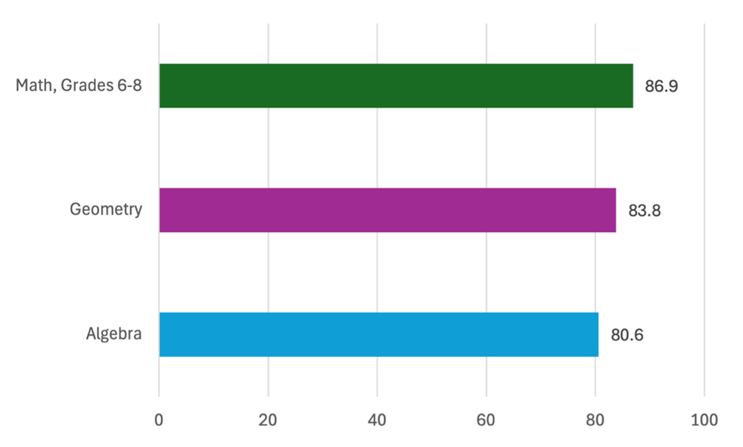

Attendance Rates

While tutors across the state averaged over 85% attendance, student attendance lagged. Tutor and student attendance are noted to have increased during Spring 24. Low attendance rates for some tutored students can be a potentially limiting factor to the benefits experienced in tutoring. Districts indicated that attendance issues were compounded by competing after-school activities.

Figure 40: High School Tutoring Attendance Rates
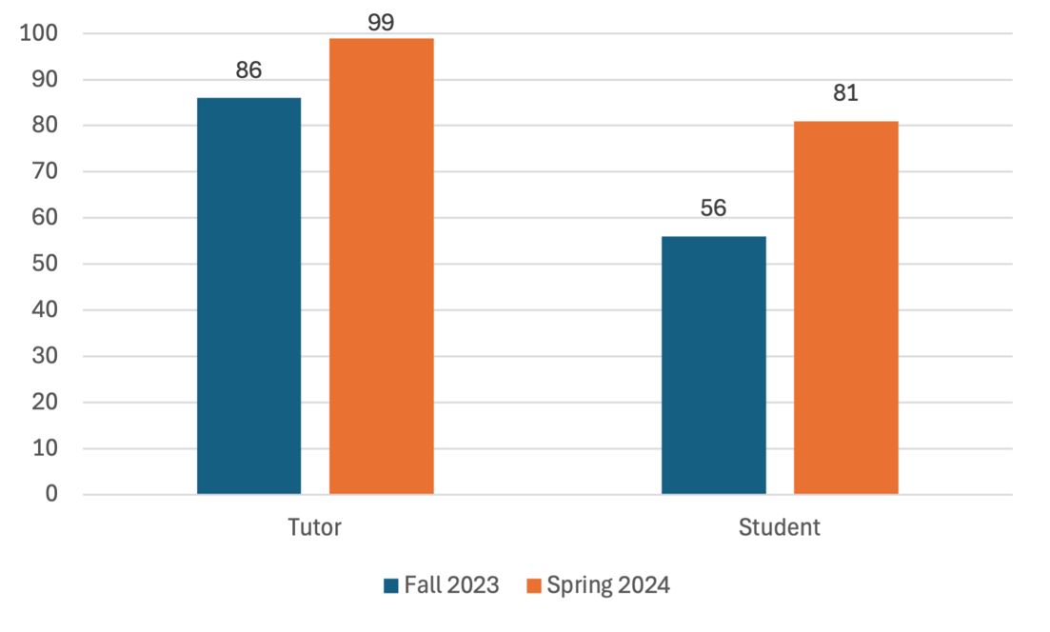

Districts and Schools

Priority high school districts were identified based on level of funding using the evidence-based funding formula, concentration of low-income students, and disproportionate COVID-19 impact. Table 10 shows priority districts and high schools served during spring, summer, and fall 2023 and spring and summer 2024. In total, the ITI partnered with 5 districts and 6 school sites for high school math tutoring.

Table 10: High School Priority Districts and Schools Served During Academic Years 2023-24

 |  |  |  | High School Online Math
 |  |  |  |  | AY22-23 |  | AY23-24 |  |  |  | AY22-23 |  | AY23-24
Districts Served |  |  |  |  | S | SU | F | S | SU | Schools by District | S | SU | F | S | SU
Shiloh CUSD 1 |  |  |  |  | X | X | X | X | X | Shiloh High School | X | X | X | X | X
Donovan CUSD 3 |  |  |  |  | X | X | X | X |  | Donovan Senior High School | X | X | X | X
Decatur SD 61 |  |  |  |  |  | X |  |  |  | Eisenhower High School |  | X
 |  |  |  |  |  |  |  |  |  | McArthur High School |  | X
Martinsville CUSD 3C |  |  |  |  |  | X |  | X |  | Martinsville Junior Senior High School |  | X |  | X
Anna-Jonesboro CHSD 81 |  |  |  |  |  | X |  | X | X | Anna-Jonesboro Community High School |  | X |  | X | X
Total: |  |  |  |  | 2 | 5 | 2 | 4 | 2 |  | 2 | 6 | 2 | 4 | 2

Sessions

High school math tutoring scaled over the course of implementation. The graphs below indicate that while many sessions were originally scheduled, completion rates increased (see green bars in graph) over time.

Figure 41: High School Tutoring Sessions AY23-AY24

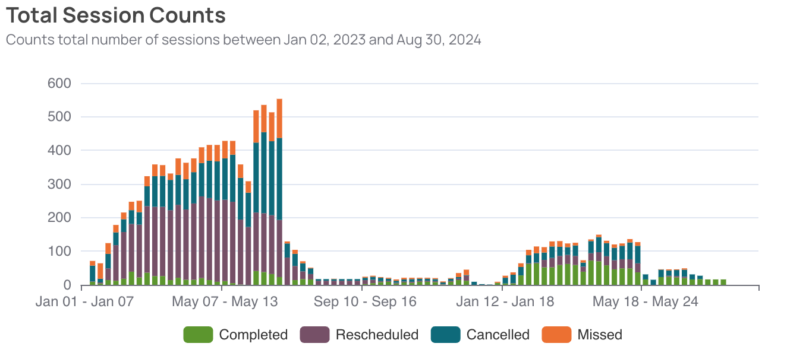

Figure 42: High School Tutoring Sessions AY24

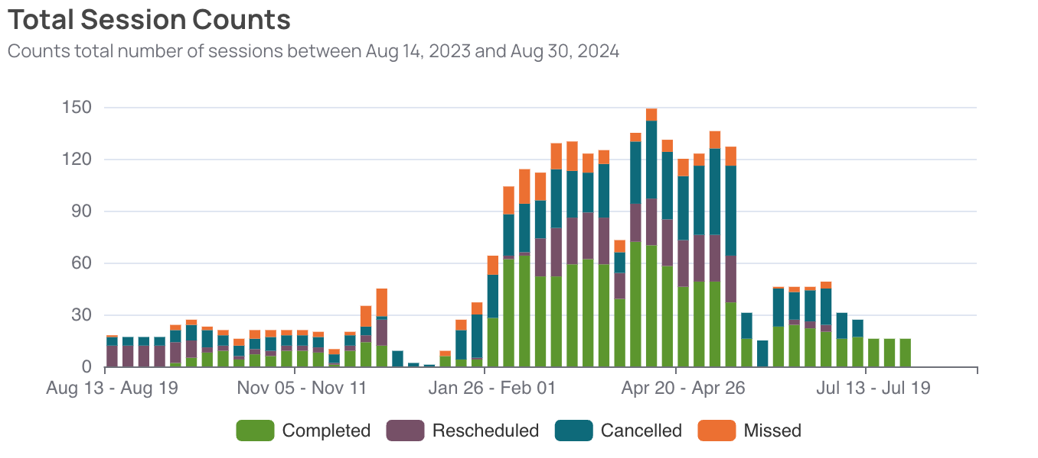

Conclusion
The Illinois Tutoring Initiative (ITI) has demonstrated a significant positive impact on student learning and tutor development during the 2023-24 academic year. Tutored students consistently outperformed their non-tutored peers in both reading and math, with particularly strong outcomes for English Language Learners and students receiving special education services. Tutors reported increased self-efficacy, supported by rigorous training and adherence to high-impact tutoring practices, as confirmed by assessments and observational fidelity checks.
The initiative’s ability to scale, coupled with strong collaborative efforts between institutional and district partners, highlights its potential to address educational inequities and build confident learners. Without continued funding, this transformative initiative ended at the conclusion of Summer 2024. The ITI remains a nationally recognized model for using high-impact tutoring to drive meaningful educational change as a statewide initiative.
For more information on the Illinois Tutoring Initiative and its mission to build confident learners through high-impact tutoring, visit: https://illinoistutoringinitiative.org.

Guthrie, J. T., Wingfield, A. (2000). Engagement and motivation in reading. In Kamil M. L., Mosenthal P. B., Pearson P. D., Barr R. (Eds.), Reading research handbook (Vol. 3, pp. 403-424). Lawrence Eribaum.

